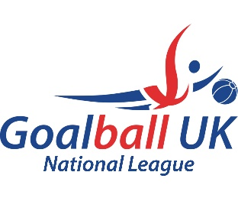

Competitors, Personnel, Supporters and Media
Photograph / Video Footage Consent Form
TO BE COMPLETED BY ANYONE WISHING TO TAKE PHOTOGRAPHS

- This form should be issued to photographers / camera operators and completed before any photograph or film imagery is taken.
- This form should be completed and handed in promptly with proof of ID to an information point to receive accreditation to photograph / film.
- This form is used to provide protection for everyone at the event and any photographers not accredited or deemed to be taking inappropriate images will have their films / recorded images removed and asked to leave the premises. Further action will be taken if deemed appropriate by the Event Management accreditation will be withdrawn.
- Photography is not allowed in any changing areas or medical areas and mobile phones with picture capability should also be registered.
- All photographers and media organisation wishing to take pictures must abide by the Child Protection in Sport Unit guidance notes for the use of images from the event. This information is available from the Event Management.
- Accreditation is transferable between days as long as the accreditation is kept in place.

To be completed by the photographer / camera operator
Name: _______________________________________________________________________________

Address (please print): __________________________________________________________________
_____________________________________________________________________________________
_____________________________________Postcode:________________________________________
Mobile Phone: _____________________________________

Please sign this statement – PARENT / GUARDIAN / PHOTOGRAPHER
I am taking photographs / video footage for the purpose of:
_________________________________________________________________
I hereby agree that all details are correct on this form and will abide by the event rules on photography.
Signature: ____________________________________________________ Date: ____/___/______
Please sign this statement – MEDIA ONLY
I understand that Goalball UK may contact me via the details above to request use of the images resulting from this photo / film shoot. This may include reproductions or adaptations of the images for all general purposes, and at any time, in relation to the work of Goalball UK.
Signature: ___________________________________________________ Date: ____/___/_____

Please hand this form to the information point. You will be issued with accreditation.
Non-Competitors should wear the wristband on the wrist, Competitors should fasten their Wristband to the relevant camera

