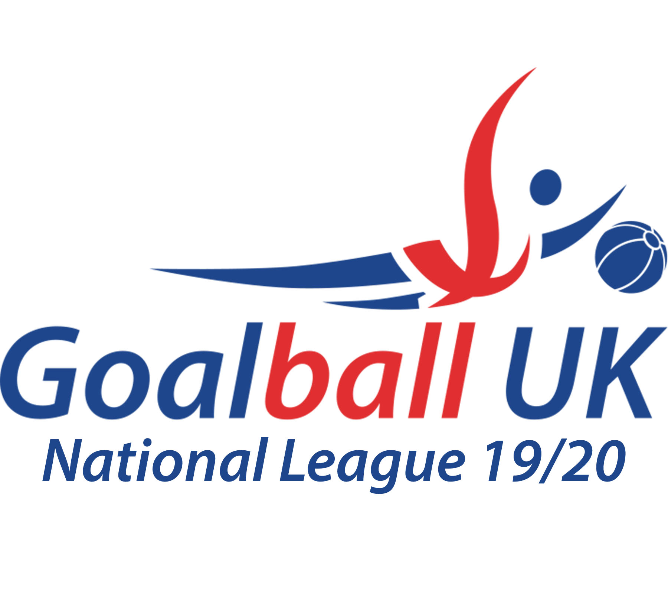
Goalball UK South & East – Intermediate Tournament
Saturday 30th November 2019 – Stanground Academy, Peterborough

Winners – Cambridge Dons Town
Position | Team Name | Points
1st | Cambridge Dons Town | 10
2nd | Fen Tigers | 8
3rd | London Elephants | 6
4th | Croysutt Warriors | 4
5th | Cambridge Dons Gown | 1
6th | Nottingham Sheriffs | 2

Time | Team A |  |  | Team B
Game 1 | Cambridge Dons Gown | 13 | 5 | Nottingham Sheriffs
Game 2 | Fen Tigers | 4 | 8 | Croysutt Warriors
Game 3 | Cambridge Dons Town | 7 | 3 | London Elephants
Game 4 | Nottingham Sheriffs | 2 | 4 | Fen Tigers
Game 5 | Cambridge Dons Town | 6 | 0 | Cambridge Dons Gown
Game 6 | London Elephants | 4 | 3 | Croysutt Warriors
Game 7 | Cambridge Dons Town | 4 | 2 | Croysutt Warriors
Game 8 | Cambridge Dons Gown | 7 | 8 | Fen Tigers
Game 9 | London Elephants | 7 | 1 | Nottingham Sheriffs
Game 10 | Croysutt Warriors | 8 | 6 | Cambridge Dons Gown
Game 11 | Cambridge Dons Town | 8 | 3 | Nottingham Sheriffs
Game 12 | London Elephants | 5 | 8 | Fen Tigers
Game 13 | Nottingham Sheriffs | 4 | 7 | Croysutt Warriors
Game 14 | Cambridge Dons Town | 4 | 5 | Fen Tigers
Game 15 | London Elephants | 7 | 0 | Cambridge Dons Gown

