SAFEGUARDING CHILDREN AND YOUNG PEOPLE

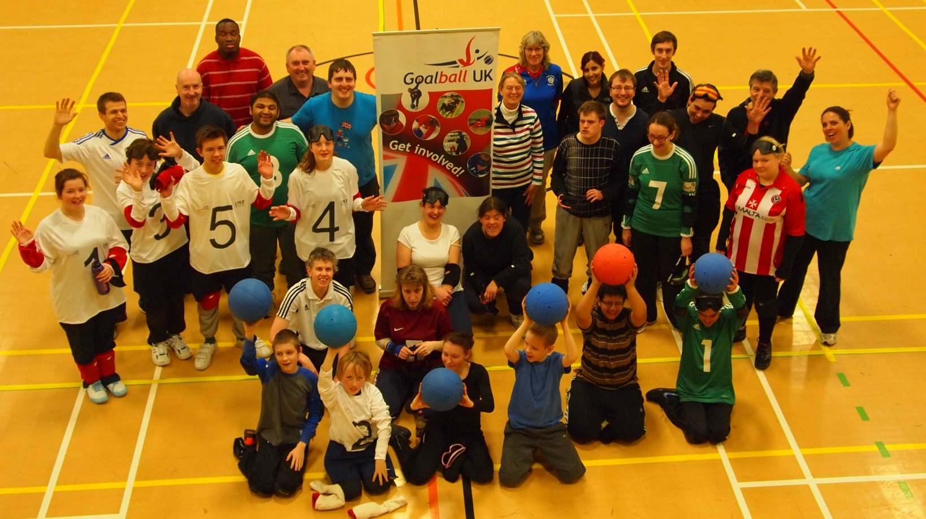
A GUIDE FOR GOALBALL CLUBS
This leaflet is designed to support Goalball Clubs providing participation, coaching and competitive opportunities for young people and adults in Goalball.
These guidelines aim to help Goalball clubs and organisations put in place practical and sensible policies and procedures. Working together we can protect and promote the welfare of all young
People and adults in Goalball so that they can enjoy the sport free from all forms of abuse and exploitation.
Every individual and organisation within Goalball has a role and responsibility to safeguard the safety and welfare of young people and adults and to ensure that Goalball activities are safe and FUN!!!
In order to ensure that procedures are followed to their utmost, Goalball UK will follow and implements the principles set out below:
- The welfare of the child is paramount.
- Goalball UK will take seriously, all concerns and allegations of abuse and respond swiftly and appropriately.
- Goalball UK recognises that working together with children, individuals, parents/guardians and the relevant safeguarding organisations is essential for the protection of children and young people.
- All persons, regardless of age, gender, ability, disability, ethnicity, religious belief and sexual identity, have a right to play Goalball in an enjoyable and safe environment and to be protected from abuse.
- Children and young people have a right to expect appropriate support in accordance with their personal and social development with regard to their involvement in the sport of Goalball.
- It is the responsibility of the child protection experts and statutory agencies to determine whether or not abuse has taken place but it is everyone’s responsibility to report any concerns.
- Personal information will be treated in strict confidence, within the limits of the law

It is the responsibility of Goalball clubs to ensure that the relevant policies are in place and that they communicated effectively to everyone involved.
All Goalball clubs and organisations should have the following policies and procedures in place.

Child Protection Policy / Adults at Risk Policy
This should include:
- When and how to report a concern, allegation, disclosure about poor practice or possible abuse.
- Who to contact should a child welfare incident or concern arise.
- Guidelines of collection by parents/carers (including what to do if a parent/carer is late when collecting a participant).

Goalball UK’s Safeguarding Children and Young People Policy and Safeguarding and Protecting Adults at Risk are available for download here: website…

Code of Conduct/Behaviour
Codes of Conduct/behaviour should be in place for; coaches, volunteers, spectators, parents/carers and participants. These should be promoted to and adopted by everyone concerned.

Goalball UK’s Code of Conduct is available for download here:
Goalball Uk weblink

Anti-Bullying Policy
Everyone within Goalball should have an understanding of what bullying is and the different forms it can occur. Bullying of any kind is unacceptable in any Goalball club. If bullying does occur, all Goalball players or parents should be able to tell and know that incidents will be dealt with promptly and effectively.
Goalball UK wishes to promote a TELLING culture and anyone who knows or suspects that bullying is happening must take the matter seriously, and report it immediately.

Health & Safety
This should include details of:
- Risk assessment procedures.
- Participants consent forms (including details of emergency contacts, medical history, special requirements and where necessary consent for photography and/or video to be taken).
- How to respond to an incident or accident.
- Who is contact/s should a health and safety concern arise.

Equity Policy/Statement
This should reflect that the rights, dignity and worth of everyone should be respected and everyone should be treated equally within Goalball. This should be reflected within the clubs’/organisations constitution.

Club Delivery Check list
The wellbeing and safety of every Goalball player performer be considered at all times in doing so the following must be considered.
Do you have valid insurance cover?
All Goalball clubs must have appropriate and up to date insurance cover.
Becoming a registered club and holding membership with Goalball UK provides your club with £5m Public Liability Insurance cover for Goalball UK recognised activities.
Do you know your participants?
It is important that as a Goalball club you have relevant details of all participants. This could include any medical information or special needs. Parents should be asked to complete a consent form where this information is provided along with emergency contact details.

Do your activities take place in a safe environment, using safe equipment?
All Goalball clubs should have risk assessments in place. Risk assessments should be undertaken (and documented) by named club personnel prior to the delivery of activities.

Are your activities appropriate?
All activities must be appropriate for the age, maturity, experience and ability of the participant.
It is recommended that all sessions are planned in advance identifying specific outcomes and appropriate activities.
Club Training Facility
Consideration needs to be made to ensure that disabled athletes can access the building, changing rooms and facilities and to make sure that the needs of player’s with disabilities are met.

Changing Rooms
- When children and young people use changing rooms, they should be supervised by two members of staff.
- Adult staff should not change or shower at the same time using the same facilities. For mixed gender activities, separate facilities should be available for boys and girls.
- If adults and young people need to share a changing facility, the club must have consent from the parents that their child/children can share a changing room with adults in the club.
- Ensure club member and carer are involved in deciding how they wish to be assisted to change, and ensure they provide full consent to any support or assistance required.

Transportation
When using transport the following should be considered:
- Coaches and club staff will be responsible for young people in their care.
- It is the responsibility of parents to transport their child/children to and from the club or activity.
- It is not the coach’s or a volunteer’s responsibility to transport the young people to and from the club or activity.
- The club must receive consent from parents for young people to participate in all competitions and away fixtures/events.
- The club will require emergency contact numbers for parents completed on the appropriate consent form.
- Use a reputable transport company which has all the necessary insurance cover.
- Sufficient supervision is on each vehicle.
- Parents/carers are issued with written information about the pickup and drop off points and times.
- Participants are not left unsupervised (i.e. dropped off and a parent/carer is not present).

Qualifications & Training
All Goalball coaches, leaders, volunteers and paid staff should have the appropriate skills, and where necessary qualifications and experience to enable them to carry out their role effectively.
All coaches / leaders must hold an up to date Goalball coaching qualification/s which are appropriate to the level being coached.

Photography and Videoing
Goalball UK is committed to providing a safe environment for young people and adults and included in this commitment is ensuring that all necessary steps are taken to protect young people and adults from the inappropriate use of their images in resources and media publications, on the internet, and elsewhere.

It is important that information regarding the concerns is recorded properly and promptly. To assist with this process, Goalball UK has developed a Safeguarding Incident Form which outlines the Information that is required, downloadable here –
Goalball Uk weblink

AS SOON AS POSSIBLE AFTER CONCERNS HAVE BEEN REPORTED TO YOU, COMPLETE THE SAFEGUARDING INCIDENT FORM AND CONTACT GOALBALL UK LEAD SAFEGUARDING OFFICER.

Useful contacts
Organisation | Contact details
NSPCC Helpline (24 hours) | Tel: 0808 800 5000  Website: www.nspcc.org.uk
Goalball UK | Goalball UK  The English Institute of Sport  Coleridge Road  Sheffield  S9 5DA  Tel: 0114 223 5670
Goalball UK Lead Safeguarding Officer | Becky Ashworth  Mob: 07975 893924  Tel: 0114 223 5670
NSPCC – Child Protection in Sport  Unit (CSPU) | Tel: 01162 34 7278,  E-mail: cpsu@nspcc.org.uk
LADO* (Local Authority Designated Officers) | Name:  Tel:  Email:
LSCB (Local Safeguarding Children’s Board | Website: www.safenetwork.org.uk/
Victim Support Helpline: | Tel: 0845 3030 900  Website: www.victimsupport.org.uk
Child line | Tel: 0800 1111  Website: www.childline.org.uk
* Please complete these details

www.goalballuk.com

Facebook.com/GoalballUK

@GoalballUK

