SAFEGUARDING CHILDREN AND YOUNG PEOPLE
A GUIDE FOR PARENTS & GUARDIANS
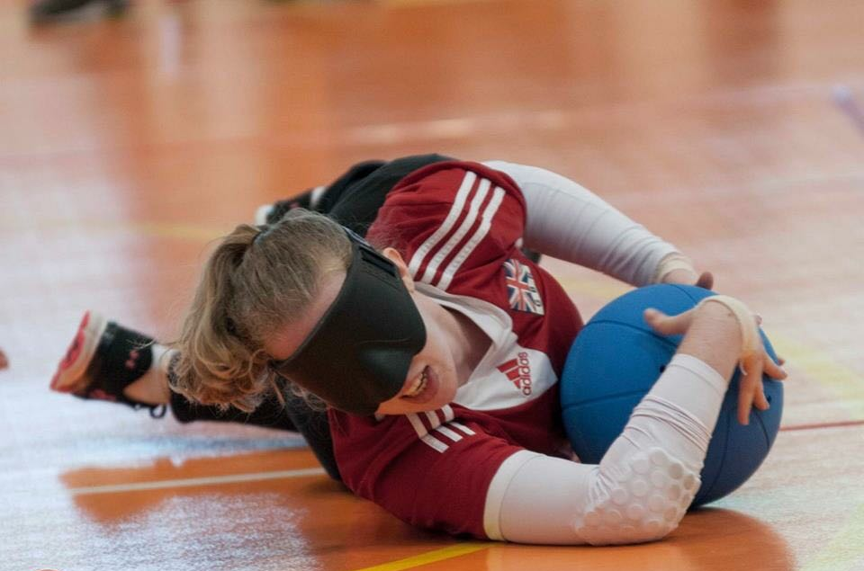

This leaflet is designed to provide parents/guardians with information on good sports practice whose children participate in goalball.
It is essential that parents/guardians have a general awareness of good practice when selecting a goalball club for a young person to attend. This will ensure that they can enjoy goalball within a safe and secure environment where they feel protected and empowered to make the most suitable choices. Providing children with positive sporting experiences means that they will be more likely to achieve their true potential.
Every young person has the right to have fun and to be safe and free from harm, whether training or playing for a local club or at a representative level. As parents/guardians you should feel comfortable with the environment that your child is in and able to ask questions about the organisation, structure, people, policies and practices of that club or organisation.
This document is designed to provide parents/guardians with information on good practice and ideas of questions to ask, and to ensure that both you and your child understand the way the club works, and your roles and responsibilities.
Every individual and organisation within goalball has a role and responsibility to safeguard the safety and welfare of young people and adults and to ensure that goalball activities are safe and FUN!!!

Questions for parents/guardians to consider

Are the coaches qualified?
All coaches/leaders must hold an up-to-date Goalball UK recognised Coaching/Leadership qualification which is appropriate to the level of activity being coached.
Do the coaches have the appropriate training?
All coaches/leaders working with young people are strongly advised to attend a SCUK Safeguarding & Protecting Children workshop and hold a first aid certificate.
Do the coaches have valid insurance cover?
All coaches need to hold insurance which covers them for a minimum of £5million for public liability.

Are the coaches and club personnel suitable to work with young people?
All coaches and volunteers who regularly cares for, trains, supervises or is in sole charge of young people should have had a DBS Check completed to the appropriate level through Goalball UK.

Does the club collect emergency contact details and medical information?
Clubs and coaches need to know contact details in case of an emergency and also need to be aware of any medication your child is taking or if they have any other particular needs. You should be asked to complete a parental consent form with this information, when you first attend an activity, but if not, inform the coach or organiser.

Who do I tell if my child takes medication?
Goalball UK clubs and coaches need to be aware of any medication that your child is taking, or if they have any other particular needs. You should be asked when you first attend an activity, but if not inform the coach.
Club Accreditation
Goalball UK’s Club Minimum Standards ‘Goal1’ recognises good practice in goalball clubs. It outlines the minimum operating standards for clubs within goalball. The accreditation ensures that the club is committed to providing a safe, effective and child-friendly environment.

Child Protection Policy / Adults at Risk Policy
The club will have formally adopted a Child protection and Adults at Risk policies, outlining procedures for dealing with possible abuse, disclosures or poor practice. You will be able to view this policy on request.

Insurance
The club has minimum public liability insurance.

Code of Conduct/Behaviour
Codes of Conduct/behaviour should be in place for; coaches, volunteers, spectators, parents / carers and participants. These should be promoted to and adopted by everyone concerned.

Goalball UK’s Code of Conduct is available for download here on the Goalball UK website

Your role as a parent/guardian

Always ensure that the young people you are responsible for have:
- The correct kit and equipment.
- A suitable drink when required.
- Medication if required.
If in doubt contact the club/organisation for specific requirements.

Always ensure that you:
- Arrange for your child to be dropped off and picked up promptly from the club and matches.
- Contact the club if you are running late to collect your child.
- Adhere to the rules of the club.
- Adhere to the Codes of Conduct/ Behaviour within the club, in particular the Parents’ Code of Conduct / Behaviour.
- Accept the guidance that coaches provide and umpires’ decisions within matches.
- Use appropriate language at all times.
- Never force your child to participate.
- Provide emergency contact details and any relevant information about your child, including medical history, and update the club if it changes.
- Become involved in the club as much as possible. This provides your child with the support to enjoy goalball.
- Support the coaches by ensuring your child enjoys playing goalball and plays within the rules of the game.
- Encourage fair play.
- Encourage your child to recognise good performance, not just results.

What do I do if I am concerned?
Contact the Goalball UK Lead Safeguarding Officer.
- Ask to speak with them and explain your concerns.
- All concerns will be taken seriously and investigated.
- All concerns will be treated in the strictest confidence, with only the people who can help the situation becoming involved if required.
Useful contacts
Organisation | Contact details
NSPCC Helpline (24 hours) | Tel: 0808 800 5000  Website: www.nspcc.org.uk
Goalball UK | Goalball UK  The English Institute of Sport  Coleridge Road  Sheffield  S9 5DA  Tel: 0114 223 5670
Goalball UK Lead Safeguarding Officer | Steve Cox  Contact details on the website
NSPCC – Child Protection in Sport  Unit (CSPU) | Tel: 01162 34 7278,  E-mail: cpsu@nspcc.org.uk
LADO* (Local Authority Designated Officers) See local phone directories, internet search engines or via Local Authority directly. | Name:  Tel:  Email:
LSCB (Local Safeguarding Children’s Board | Website: www.safenetwork.org.uk/
Victim Support Helpline: | Tel: 0845 3030 900  Website: www.victimsupport.org.uk
Child line | Tel: 0800 1111  Website: www.childline.org.uk
* Please complete these details
www.goalballuk.com

Facebook.com/GoalballUK

@GoalballUK

