

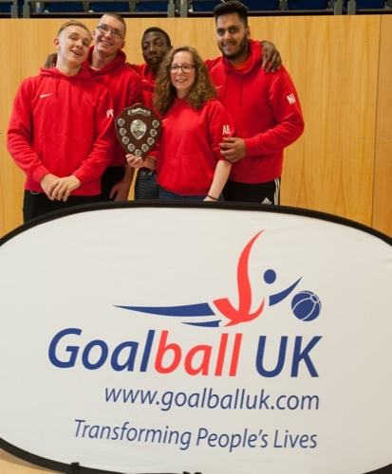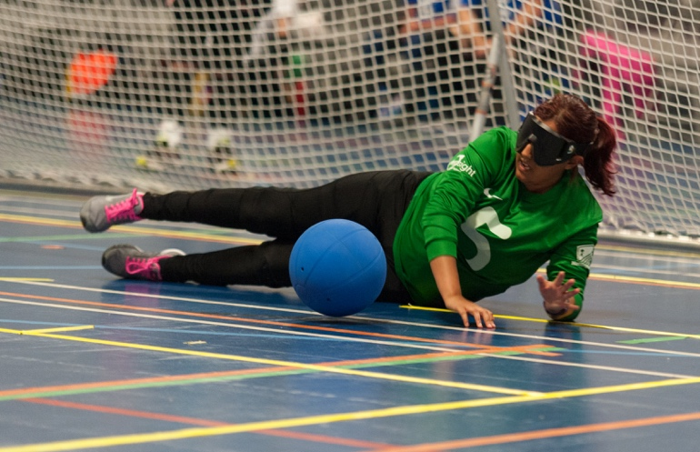

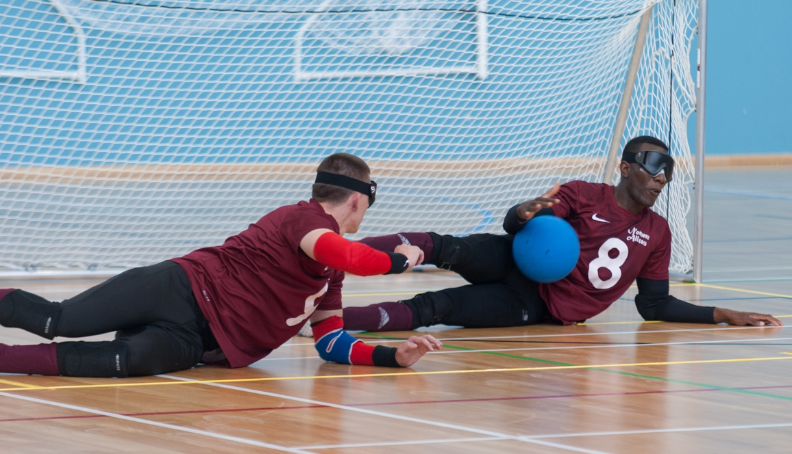

**GOALBALL UK:**

**DIVERSITY ACTION PLAN [2017 – 2019]**

**ABOUT US**

|  |
| --- |
| Goalball UK is the National Governing Body (NGB) for Goalball in the United Kingdom and is the representative of Goalball in England, Wales, Scotland, and Northern Ireland. Goalball is a charitable company limited by guarantee, incorporated on 26th February 2010 and registered as a charity in July 2010. The company is governed by its Memorandum and Articles of Association which establish the objects and powers of the company. The affairs of the charitable company are governed by a “Board of Trustee Directors”. The trustees are accountable for ensuring that Goalball UK meets its charitable objectives and for the overall performance of the company. Goalball was originally developed as a rehabilitation programme for visually impaired World War II veterans. It has grown into a highly competitive sport played by VI athletes in over 70 countries, has its own European and World championships and is a key Paralympic event. It is a sport that undoubtedly can positively change an individual’s makeup, personality, and whole being not just in its inheritant physical and social benefits to visually impaired people but truly creating a sporting habit for life. |

**OUR MISSION**

|  |
| --- |
| “To raise the profile of Goalball throughout the UK, promote participation in the sport and achieve success on the international stage.” |

**OUR VISION**

|  |
| --- |
| “As the NGB for Goalball in the UK, to be recognised nationally and internationally as creating the best possible environment, structure and facilities for the development of Goalball players in the UK to compete both domestically and internationally.” |

**OUR VALUES**

|  |
| --- |
| • To ensure all our people are valued  • To promote integrity, responsibility and endeavour  • To be inclusive in everything we do  • To encourage the development of our players from playground to podium  • To continually strive for sporting excellence |

**Message from Our Chair**

“As a Board of Directors we all recognise a diverse group of individuals with varied opinions and backgrounds can only benefit the leadership, governance, and strategic decision making processes for Goalball UK (England & Wales Registered Charity Number 1136892, Scottish Registered Charity Number SC045967).

The Board members and I are fully committed to striving for greater diversity within Goalball UK as an entire community in order to achieve long term benefits for the sport.

As a relatively new National Governing Body we are proud that the culture that has developed is tolerant, diverse and, above all, welcoming to all members of society. The subculture that has been created truly does help to Transform people’s lives.

We have recently appointed a new CEO and we have identified that a priority for the next 12 months is to revisit our Mission, Vision and Values and ensure that they represent where our sport presently is and reflects where we want to progress. We feel we have moved on from the existing Mission, Vision and Values.

Therefore, I am delighted that the Board has unanimously approved this action plan and that we will begin working towards demonstrating the equality standards that we know are inherent within our sport.”

John Coles

(Chairperson)

**Our Commitment to Diversity and Inclusion**

Goalball UK is fully committed to working towards demonstrating the good practice within the sport by working within the Equality Standard framework. It is a long term ambition to work towards the Advanced Equality Standard.

Goalball UK’s mission, vision values and priorities will be realigned within the next twelve months as part of the formation of a new strategic plan. This will revisit and embed its equality and diversity values into every day practice, policies and procedures so that equality and diversity becomes explicit within our community. This will will be driven by the Board and senior staff but will be embedded across the workforce as well as clubs and members.

As a Paralympic sport, played largely by blind and partially sighted people, Goalball UK supports and recognises the importance of diversity in its broadest sense throughout its organisation, including on its Board. We are committed to ensuring that our players are represented at board level. We are also committed to the voice of our youngest members and will form a ‘Young Person’s Reference group’; their views will be shared with the board and influence decisions.

As an employer, Goalball UK believes in fairness and equity and values diversity. We recognise a diverse organisation will value and benefit from differences in sports skills, regional and industry experience, background, race, gender, sexual orientation, religion, belief and age, as well as culture and personality.

Currently 33% of the Goalball UK Board is female. In accordance with the mandatory requirements of the Code for Sports Governance, Goalball UK will continue to encourage diverse candidates for Board roles. We are committed to meeting the target of achieving a minimum of 30% of each gender on its board and ultimately to achieving gender parity on the Board.

In accordance with the Code for Sports Governance, Goalball UK reviews the Board’s effectiveness and composition each year and, in particular,considers the balance of skills, experience and independence of the Board. It also considers the benefits of all aspects of diversity, but without compromise as to the calibre of directors, when identifying candidates for appointment.

We recognise that leadership and decision making is greatly improved when a Board is able to draw on and harness a diverse range of opinions. Thus, in order to drive greater diversity, the Board has agreed this action plan which will be reviewed annually. The Board will monitor progress against the actions below and support a new three year action plan based on the work involved in the Equality standards and a realigned statement of Vision, Values and Mission within a strategic plan.

**4. Action Plan Objectives**

* Focus on encouraging diverse high calibre candidates for Board and staff roles.
* Consider candidates for all appointments from a wide pool.
* Ensure Board appointment ‘long lists’ include diverse candidates.
* Report against these objectives and other initiatives to promote diversity annually.
* Report annually on the outcome of the Board evaluation including the diversity of the composition of the Board and meeting the target of a minimum of 30% of each gender on the Board and ultimately gender parity on the Board

**5. Indicators**

As a governing body we are committed to ensuring that our membership is representative of the UK population. We will establish a benchmark of the levels of diversity within our membership and ensure that we continue to monitor and act upon under-representation.

This action plan has been approved by Goalball UK on 29th November 2017. It is part of a wider good governance strategy which notes and promotes the principles of the Code for Sports Governance.

Mark Martin presently has the role of Head of Governance and Compliance. He is responsible for overseeing delivery of this action plan, working in conjunction with the CEO, all members of the Senior Management Team and the Board itself.

|  |  |  |  |  |  |  |  |  |  |
| --- | --- | --- | --- | --- | --- | --- | --- | --- | --- |
| **Recruitment**  How the organisation will attract an increasingly diverse range of candidates | | **Code for Sports Governance** | | | | | | | |
| **Adopt a target of, and take all appropriate actions to encourage, a minimum of 30% of each gender on its board** | **Demonstrate a strong and public commitment to progressing towards gender parity and greater diversity generally on its board** | **Demonstrate a strong and public commitment to progressing towards achieving greater diversity generally(including but not limited to BAME, disability, LGB&T and socio-economic)** | | **Each organisation shall identify proportionate and appropriate actions to be taken to support and/or maintain (as appropriate) the diversity targets set out in Req 2.1** | **The board shall ensure that the organisation prepared and publish on its website information (approved by the Board) about its work to foster all aspects of diversity with its leadership and decision making)** | | **The board shall ensure the organisation prepared and publishes on its website information (approved by the Board) including an annual update on progress against actions identified in Req 2.2** |
| **Objective:** Embed good diversity and inclusion practiceinto our recruitment activities and decision making processes | | √ | √ | √ | | √ | √ | | √ |
| **Priorities** | **Actions** | | | | **Person(s) Responsible** | | | **Completion Date** | |
| **Short Term:** | The Board and Staff Recruitment Procedures ensure that all positions are widely advertised. This includes advertisement with websites such as ‘RNIB’, ‘Guidedogs for the Blind’, ‘British Blind Sport’, ‘English Federation for Disability Sport‘, Black Solicitors Network’, ‘Sporting Equals’, ‘Inclusive Boards’and ‘Women in Sport. | | | | Head of Governance and Compliance | | | Ongoing | |
| **Short Term:** | Board Evaluation and Equality Monitoring Audit. This annual audit will analyse the diversity of the Board. The results of this has and will continue to influence the appointment of Independent Non-Executive Directors. | | | | Head of Governance and Compliance & Audit committee | | | Ongoing | |
| **Short Term:** | **Publishing**  Publish details of Board diversity profile online.  Publish this Action Plan | | | | Head of Governance | | | October 2017 | |
| **Short Term:** | Management Board Skills Matrix. This matrix will assess the skills on the Management Board to determine any skills gaps. The results of this has and will continue to influence the appointment of Independent Non-Executive Directors. | | | | Head of Governance | | | November 2017/ Ongoing | |
| **Medium Term:** | As vacancies arise actively seek representation on Board and Board committees and working groups through positive action, e.g. guaranteed interview scheme.  Continue to Engage with organisations which represent those under- represented groups and which may be able to assist with identifying candidates.  Women in Sport  English Federation of Disability  Sports Sporting Equals  Board Level Posts will be advertised as widely as possible so as to attract a diverse group of candidates and reference will be made to this in the Recruitment Briefing.  Attention will be paid to how the advertisement and role profile/person specification is written to be sure it is not precluding any applicants.  Consider use of recruitment consultant to widen even further. Hold them to account if they have been used to show what steps they have taken to ensure diversity. | | | | Head of Governance and Compliance/ CEO  Head of Governance  Appointments approved by Board | | | As required/ Ongoing | |
| **Long Term:** | At least 12.5% (one member of Management Board) to be BAME by 2022 AGM.  Gender parity at Board level by 2020 AGM | | | | Head of Governance and Compliance  Head of Governance And Compliance | | | AGM 2022  AGM 2020 | |

|  |  |  |  |  |  |  |  |  |  |
| --- | --- | --- | --- | --- | --- | --- | --- | --- | --- |
| **Engagement**  Ensuring that your organisation’s commitment to diversity is communicated through internal practices and externally | | **Code for Sports Governance** | | | | | | | |
| **Adopt a target of, and take all appropriate actions to encourage, a minimum of 30% of each gender on its board** | **Demonstrate a strong and public commitment to progressing towards gender parity and greater diversity generally on its board** | **Demonstrate a strong and public commitment to progressing towards achieving greater diversity generally(including but not limited to BAME, disability, LGB&T and socio-economic)** | | **Each organisation shall identify proportionate and appropriate actions to be taken to support and/or maintain (as appropriate) the diversity targets set out in Req 2.1** | **The board shall ensure that the organisation prepared and publish on its website information (approved by the Board) about its work to foster all aspects of diversity with its leadership and decision making)** | | **The board shall ensure the organisation prepared and publishes on its website information (approved by the Board) including an annual update on progress against actions identified in Req 2.2** |
| **Objective:** Communicate our commitment to diversity in all activities | | √ | √ | √ | | √ | √ | | √ |
| **Priorities** | **Actions** | | | | **Person(s) Responsible** | | | **Completion Date** | |
| **Short Term:** | To publish details of the diversity of the staff and directors of the company | | | | Head of Governance and Compliance | | | December 2017 and annually within AGM | |
| **Short Term:** | To publish the Board Diversity Statement, highlighting our commitment to diversity throughout the company and in all business activities, on the company website | | | | Head of Governance and Compliance | | | December 2017 and annually highlight within AGM | |
| **Short Term:** | To ensure that the website and social media content continues to promote our commitment to diversity on all governance and company pages | | | | CEO | | | Ongoing | |
| **Medium Term** | To arrange a Management Board Equality and Diversity Training Session | | | | Head of Governance and Compliance | | | 2018 | |
| **Medium Term** | To pass the Intermediate Equality Standards in Sport | | | | Head of Governance and Compliance/ CEO | | | 2018 (dependeding on capacity at Sport England) | |
| **Long- Term** | To ensure our commitment to diversity is contained within the company Strategy 2018-2023 | | | | Head of Governance and Compliance/ CEO | | | End of 2018 and ongoing | |
| **Long-Term** | Advanced Equality Standards in Sport | | | | Head of Governance and Compliance/ CEO | | | End of 2020 | |

|  |  |  |  |  |  |  |  |  |  |
| --- | --- | --- | --- | --- | --- | --- | --- | --- | --- |
| **Progressing talent from Within**  A focus on developing a strong internal pipeline of diverse talent to populate decision making and other structures. | | **Code for Sports Governance** | | | | | | | |
| **Adopt a target of, and take all appropriate actions to encourage, a minimum of 30% of each gender on its board** | **Demonstrate a strong and public commitment to progressing towards gender parity and greater diversity generally on its board** | **Demonstrate a strong and public commitment to progressing towards achieving greater diversity generally(including but not limited to BAME, disability, LGB&T and socio-economic)** | | **Each organisation shall identify proportionate and appropriate actions to be taken to support and/or maintain (as appropriate) the diversity targets set out in Req 2.1** | **The board shall ensure that the organisation prepared and publish on its website information (approved by the Board) about its work to foster all aspects of diversity with its leadership and decision making)** | | **The board shall ensure the organisation prepared and publishes on its website information (approved by the Board) including an annual update on progress against actions identified in Req 2.2** |
| **Objective: Encouraging employees to undertake ‘continuing professional development’, to attend committee meetings, leadership programmes and external courses and to utilise the senior members of the staff team, stakeholders, panel members and board members as mentors in order to promote from within.** | | √ | √ | √ | | √ | √ | | √ |
| **Priorities** | **Actions** | | | | **Person(s) Responsible** | | | **Completion Date** | |
| **Short Term:** | Publish this report and commitment on website and also circulate via email to key volunteers. | | | | Head of Governance and Compliance/ CEO | | | December 2018 | |
| **Medium Term:** | All employees to undertake ACAS Equality & Diversity online training and all new starters to undertake the training as part of induction process | | | | CEO | | | 2018 | |
| **Long Term:** | Encouraging Board applicants when there is a vacancy from:  Known contacts working in the sport.  Known contacts working in other sports.  Those already on working groups or panels  Key volunteers and ex-athletes  Long term benefits can be Use of existing skills of the sport and or the sector. Knowledge of the sport and organisation Development and acknowledgment of the skills of volunteers. Can be targeted e.g. Para Athletes who have recently retired. | | | | Head of Governance and Compliance –  Chief Executive  Senior Management Team | | | Ongoing | |

Key Questions

**Who are the key people responsible for the delivery of this plan?**

|  |
| --- |
| Mark Martin (Head of Governance and Compliance), Mark Winder (CEO), Becky Ashworth (National Development Manager), John Coles (Chairperson) are responsible for the delivery of the plan, however the Board will oversee the implementation. |

**How will we measure overall success?**

|  |
| --- |
| Overall success will be measured by:   * Achieving the Foundation, Preliminary and Intermediate Equality Standard * Capturing data and demonstrating that Board and staff recruitment drive has attracted more diverse candidates. * Meeting initially the target of a minimum of 30% of each gender on the Board and working towards Board gender parity. |

**How does your Diversity Action Plan (DAP) cross-reference other parts of the code or other relevant equality or diversity monitoring standards/framework?**

|  |
| --- |
| We are presently exploring the Equality Standard Framework with Sport England and the Stonewall Workplace Equity Index process. |