Goalball UK Player Uniform in Competition Guidance
Updated May 2021

Regulations
For all Goalball UK competitions, players must be appropriately and individually numbered, back and front. Numbers must be 1,2,3,4,5,6,7,8 or 9 and must be a minimum of 18cms high and clearly distinctive.

Novice
Numbers printed or embroidered on playing shirts at advisable at Novice level. However, bibs can be used if required.

Intermediate
Numbers printed or embroidered on playing shirts are mandatory at Intermediate level with the exception of a clubs first competition.

Elite
Numbers printed or embroidered on playing shirts are mandatory at Elite level, with no exceptions.

What happens if we do not have the correct player uniform?
Failure to comply with uniform regulations in competition will lead to a Team Delay of Game Penalty for every game your team fails to meet the regulation.

Recommended Player Shirt Design

Brand logo left chest as you look at the shirt
Club logo right chest as you look at the shirt
A clear distinctive number (1-9) a minimum of 18cms high on the back and front of the shirt
Any remaining space can be used for additional branding, player name, or club name but it must not obstruct or cover up any part of the number.
The image below shows an example shirt layout.
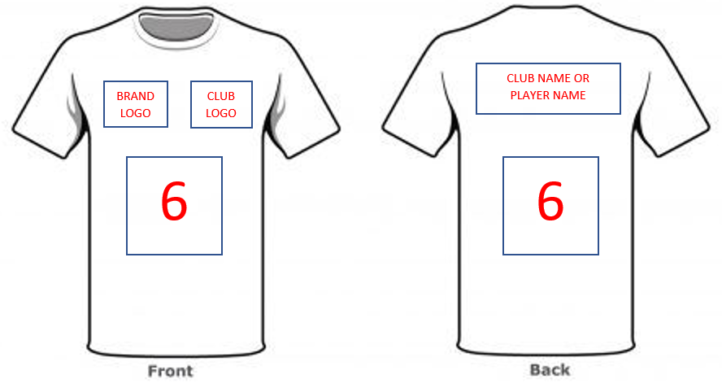

Document End.

