SAFEGUARDING CHILDREN AND YOUNG PEOPLE
A GUIDE FOR GOALBALL COACHES & LEADERS
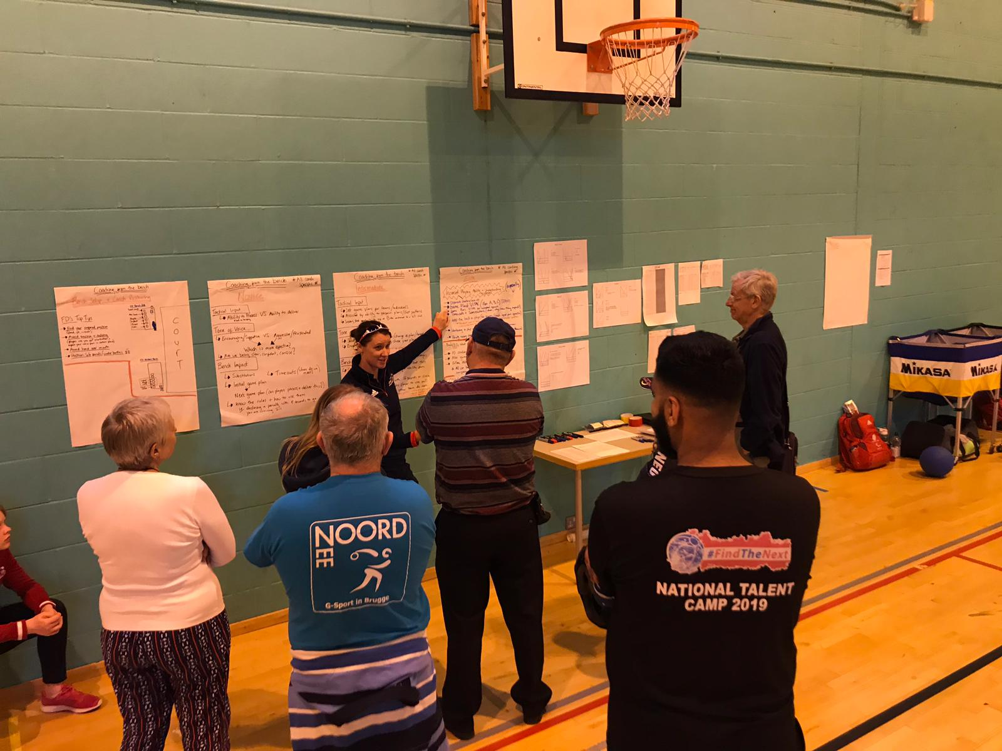
This leaflet is designed to support goalball coaches / leaders by providing information and guidance on the implementation of good practice within a goalball club.
This guidance has been produced specifically for coaches and leaders who provide opportunities for young people and adults in goalball.
Every individual and organisation within goalball has a role and responsibility to safeguard the safety and welfare of young people and adults and to ensure that goalball activities are safe and FUN!!!
As a goalball coach or leader you will develop strong positive relationships with young people and become a role model. You should adopt the highest standards, as you have a vital role in providing a fun and safe environment in which young people can enjoy goalball. You must be aware of your duty of care and current guidance on good practice, and act responsibly when you are around young people. This will safeguard and protect the young people you coach and reduce the potential for misunderstandings and inappropriate allegations being made.

As a goalball coach what do you need to know?
Every child and young person has the right to have fun, be safe and free from harm. It is essential that goalball coaches and leaders adopt good practice when dealing with children and ensure that their safety is paramount.

Policies and procedures
It is the responsibility of the club to ensure that the relevant policies and procedures are in place and communicated and for the coach/leader to be aware of and follow these.

Child Protection Policy / Adults at Risk Policy
Coaches/leaders should be aware of and follow the club / organisations or Goalball UK’s relevant child protection policy. Ensure they fully understand the following:
- When and how to report a concern, allegation, disclosure about poor practice or possible abuse.
- Who to contact should a child welfare incident arise.
Goalball UK’s Safeguarding Children and Young People Policy is available for download on the Goalball UK website

Equity
All coaches / leaders should be aware of, and follow the appropriate club / organisations equity policy.
The rights, dignity and worth of everyone should be respected and everyone should be treated equally within the context of their sport.

Health & Safety
All coaches / leaders should be aware of, and follow the appropriate club / organisations health & safety policy. This should include:
- Risk assessments.
- Participants consent forms including details of emergency contacts, medical history and consent for photography and video to be taken.
- How to respond to an incident or accident.
- Who to contact should a health and safety concern arise.

Codes of Conduct
Coaches/leaders should be aware of and follow the relevant club / organisations or Goalball UK’s coaches code of conduct.

Photography and Videoing
Consent for taking photographs or videos should be obtained from parents in advance, all photography and videoing needs to comply with a club/organisations child protection policy.
Any concerns regarding the use of photography or videoing should be reported to a designated child protection/Goalball UK’s Lead Safeguarding Officer.

Qualifications & Training
All coaches / leaders must hold an up to date goalball coaching qualification/s which are appropriate to the level being coached.

Coaching Delivery Check list
Coaches/leaders must at all times place the wellbeing and safety of the performer first, in doing so the following must be considered.
Are your activities appropriate?
Coaches/leaders must ensure the activities are appropriate for the age, maturity, experience and ability of the individual. It is recommended that all coaches/leaders plan sessions in advance identifying specific outcomes and appropriate activities.

Do you know your participants?
As a coach/leader it is important that you have relevant details of participants which may affect their involvement in goalball; this includes medical information or particular learning needs/ disabilities. Parents MUST complete and sign a consent form providing this information and emergency contact details.

Do you have valid insurance cover?
All Coaches/leaders must have appropriate and up to date insurance cover.
All goalball clubs must have appropriate and up to date insurance cover.
Becoming an affiliated club and holding membership with Goalball UK provides your club with £5m Public Liability Insurance cover for Goalball UK recognised activities.

Is the environment and equipment safe?
A risk assessment should be carried out prior to the session by either the coach or the activity organiser.

Have you completed a DBS disclosure through Goalball UK?
All coaches/leaders that have regular, significant access or responsibility for working with young people, in a paid or unpaid capacity, should complete a DBS disclosure to the appropriate level through Goalball UK.
More information is available on the Goalball UK website
This is the responsibility of your club or organisation, you should have been asked by them to complete a CRB disclosure.

Do you know what to do in case of an incident, accident, allegation, or disclosure?
Coaches/leaders should be aware of and follow the policies and procedures of the club / organisations or Goalball UK’s, and have all the relevant reporting forms and emergency contact details available at all activities.
As a coach or leader in goalball you are not expected to be an expert in recognition; however all people working within goalball have a duty of care to be vigilant and respond to suspicions of poor practice, abuse or bullying appropriately. This does not mean that it is your responsibility to decide if a situation is poor practice, abuse or bullying, but it is your responsibility to report your concerns.
It is not your responsibility to decide if a child is being abused or poor practice has occurred. Any concerns or allegations will be managed by Goalball UK, with the club’s co-operation and assistance.
To respond to a disclosure from a child If you witness or become concerned about someone’s behaviour, or someone tells you they or another person is being or has been abused you should:

Do’s
1 | Stay calm – do not rush so you don’t frighten the individual, as this may lead to the with-holding of information.
2 | Always reassure – the individual that he/she is not to blame that they were right to raise awareness of this issue.
3 | Follow confidentiality procedures – this includes telling the individual that you may have to inform others to help stop the abuse. Confidentiality must be maintained but any concerns or information relating to possible abuse must be shared on a need to know basis.
4 | Ensure the safety of the individual – if urgent medical attention is required, then call an ambulance, inform the paramedics/doctor of concerns and ensure they are aware of the safeguarding/protection issue.
5 | Take notes - Completion of the incident report form. All concerns will be treated with a ‘non-judgemental ‘and ‘open mind’ and be handled in a fair and equitable manner.
6 | You – in order to ensure that your wellbeing is not hindered during a safeguarding issue please be aware that there are support mechanisms for you to access. If you think the situation is an emergency, contact Goalball UK LSO. If they are not immediately available then you should contact your local Children’s Social Care, LADO or Police without delay. Expert advice can also be provided by the NSPCC Helpline on 0808 800 5000.

Don’ts

1 | No Rushing – into actions that may be inappropriate. Do not approach the alleged accuser and do not take actions that may compromise/destroy evidence e.g. washing clothes, showering etc.
2 | Express your emotions and or make promises – the individual will need reassurance not an emotional response, blame or denial. Don’t guarantee promises you cannot keep.
3 | Take sole responsibility – ensure that you consult, refer and hand on appropriately.
4 | Speculate or make assumptions – outcomes will be focused on evidence and fact. In addition do not assume that someone else is aware of the abuse and that they are taking action to stop the abuse.
5 | Interview the child or probe them for detailed information as this could compromise future police enquiries. Ascertain basic information in order to pass the concern on.

It is important that information regarding the concerns is recorded properly and promptly. To assist with this process, Goalball UK has developed a Safeguarding Incident Form which outlines the Information that is required, downloadable on the Goalball UK website
AS SOON AS POSSIBLE AFTER CONCERNS HAVE BEEN REPORTED TO YOU, COMPLETE THE SAFEGUARDING INCIDENT FORM AND CONTACT THE GOALBALL UK LSO.

Useful contacts
Organisation | Contact details
NSPCC Helpline (24 hours) | Tel: 0808 800 5000  Website: www.nspcc.org.uk
Goalball UK | Goalball UK  The English Institute of Sport  Coleridge Road  Sheffield  S9 5DA  Tel: 0114 223 5670
Goalball UK Lead Safeguarding Officer | Steve Cox  Details available on the website
NSPCC – Child Protection in Sport  Unit (CSPU) | Tel: 01162 34 7278,  E-mail: cpsu@nspcc.org.uk
LADO* (Local Authority Designated Officers) | Name:  Tel:  Email:
LSCB (Local Safeguarding Children’s Board | Website: www.safenetwork.org.uk/
Victim Support Helpline: | Tel: 0845 3030 900  Website: www.victimsupport.org.uk
Child line | Tel: 0800 1111  Website: www.childline.org.uk
* Please complete these details
www.goalballuk.com

Facebook.com/GoalballUK

@GoalballUK

