Goalball UK – Club Minimum Standards
1. Consistent Training Sessions

To meet the Goalball UK Club Minimum Standards, you are expected to have at least 10 training sessions every season at a designated venue(s). You need to select a venue that is appropriate for playing goalball in (thinking about the size, sound and surface of the sports hall) which is also accessible to VI participants. We have created some guidance to make this process a little easier:
Before booking a venue
Investigate the possible routes and time taken to travel to the venue via public transport. Remember that a training session that starts early or finishes late could be problematic - not just because of limited public transport options but also because some participants might be reluctant/less confident to travel at these times during the winter months (when it is likely to be dark).
Check the availability of the venue. Is it open during school holidays? Does the sports hall get used for exams during the summer or by football teams during the winter?
Is the venue affordable? Are discounts available for block bookings or disabled users?
Make sure that the sports hall is big enough for a full court (18m x 9m), with additional space around the perimeter for safety, and that there is no background noise/background noise can be kept to a minimum.
With the permission of the venue manager, do a ‘tape test’ to ensure that the court marking tape won’t damage the floor and ask if there is the option for equipment to be securely stored there between training sessions.
Ask for a copy of the venue’s risk assessment (See Minimum Standard 6. Risk Assessments) and discuss emergency evacuation and first aid procedures – you will then need to incorporate this into your activity risk assessment.
Agree where is the best place for guide dogs to be during a training session (if their owner doesn’t want them to be in the sports hall with them). If the venue is open to the public, it is best that guide dogs are in a private area (e.g. staff office) rather than a public area (e.g. changing rooms).

Politely signpost venue staff to ‘Good Practice Guidelines’ and CPD opportunities provided by VI organisations (e.g. RNIB, Guide Dogs, British Blind Sport, etc.).
Promoting your training session
Share details of your training sessions (see Minimum Standard 14. Communication and 15. Partnerships).
Speak to new players before they attend their first training session (See Minimum Standard 8. Memberships) to ensure that they have all the information they need (e.g. when the training session is, where the training session is, what they need to bring with them, how they can get there, etc.).
For example, the image below shows a map of the area surrounding a venue in Birmingham that Goalball UK use for tournaments. There are arrows pointing at the nearest train station (Longbridge), main road (A38), hotel (Premier Inn) and supermarket (Sainsburys) as well as the actual venue (The Factory).
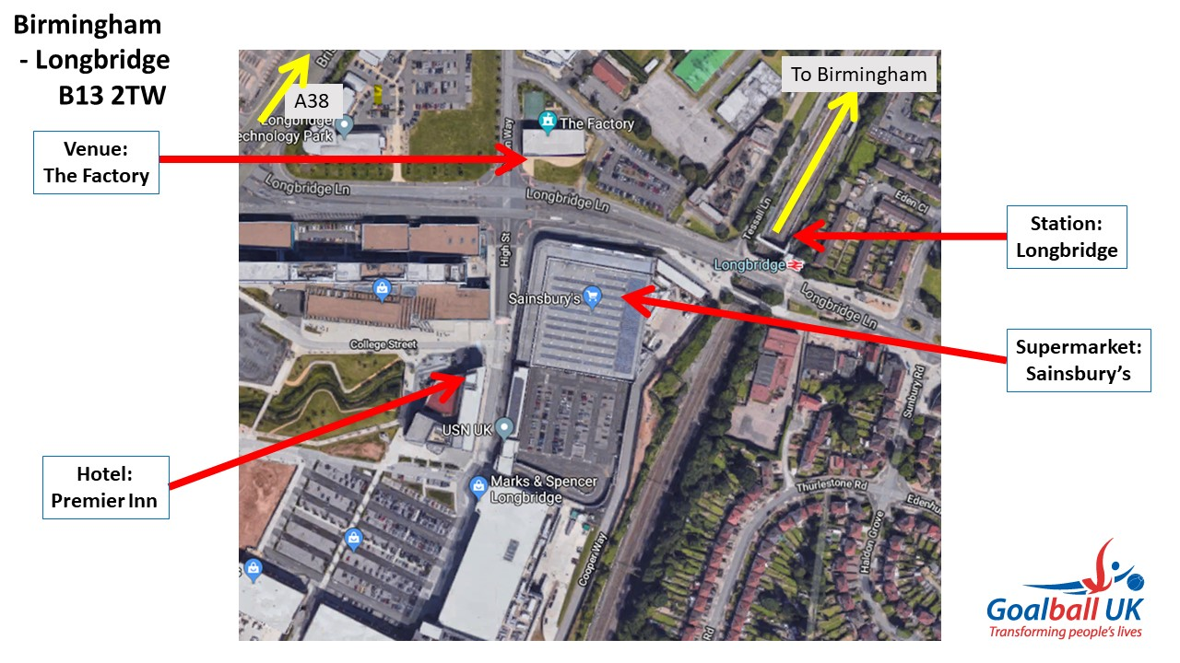

Having a central meeting point (e.g. at the nearest bus stop or train station) so participants can travel part of the way to the venue together is beneficial.
Make sure any new participants have the name and number of someone to contact should they have any travel issues on the day – a lot of clubs have WhatsApp groups to help everyone stay connected.
Before, during and after training sessions
Make sure all participants are greeted on arrival and are familiar with the layout of the venue. Do they want meeting at reception, outside the main entrance, from a taxi in the car park, at the nearest bus stop, etc.? Can they safely and independently find their way to/from the sports hall, changing rooms, toilets, café, water fountain, etc?
Always check the activity risk assessment at the start of a training session and immediately report any concerns to venue staff (e.g. if badminton posts have not been put back into the equipment cupboard).
At the end of a training session, make sure that everyone has all of their personal belongings and are met by a parent, partner, friend, etc. Or if they are travelling independently, their taxi has arrived, they know the route to walk home, the bus stop, the train station, etc.
Make sure all the equipment is safely stored (or taken home to be washed e.g. spare eyeshades and pads) ready for the next training session.
Speak with participants to ask for any direct feedback on the training session.
Encourage participants to share their experiences on social media. (See Minimum Standard 13. Social Media).

Should you need any additional information in relation to training sessions (including finding an appropriate venue) please contact Tom Dobson at Goalball UK.

Tom Dobson
Club and Competitions Development Officer
Tom.Dobson@goalballuk.com
Mobile: 07526 169288

