Goalball UK Safeguarding - A guide for Staff and Volunteers

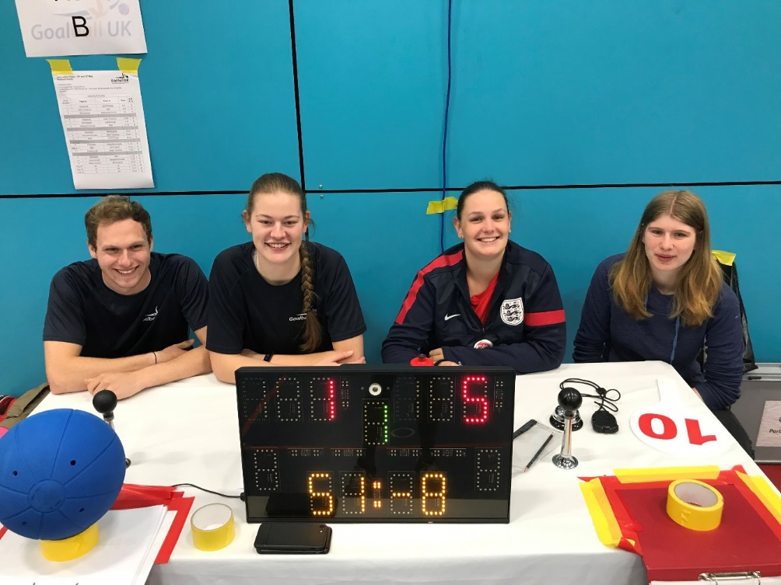

Introduction
This leaflet is designed to support Goalball UK staff and volunteers by providing information and guidance on Goalball UK’s responsibilities towards safeguarding and protecting children and adults at risk.
As a National Governing Body of sport, Goalball UK has a moral and legal obligation to ensure that the highest possible standard of care is provided for everyone involved in the sport. Therefore, through the development, communication and implementation of our safeguarding policy we aim to maintain and increase the professionalism and safeguards of good practice that have been set as standard throughout our sporting landscape.

As a Goalball UK staff member or volunteer what do you need to know?
It is essential that all staff and volunteers adopt good practices when dealing with children and adults, ensure that their safety is paramount and are confident to respond to a disclosure, suspicion or allegation and follow the correct reporting procedures.
You’re not expected to memorise each policy word for word, however there are sections and information detailed below that will ensure you feel more confident about safeguarding within goalball.

Goalball UK Policies and Documents
All poilcies and doucments related to Goalball UK Safeguarding can be found on the Goalball UK website safegaurding page.

Good Practice Guidelines
- Everyone is encouraged to demonstrate exemplary behaviour in order to promote welfare and reduce the likelihood of allegations being made.
- Some children and adults may be more vulnerable to abuse or find it more difficult to express their concerns. For example, a disabled child or adult who relies on a carer to help them get changed may worry that they won’t be able to take part any more if they report the carer. A child or adult who has experienced racism may find it difficult to trust an adult from a different ethnic background.
With this in mind, we expect everyone involved in goalball to follow the following common sense guidelines.
- Avoid spending any time working with children in isolation.
- Avoid touching or hugging of players and other volunteers or staff.
- Do not take children alone in a car, however short the journey.
- Do not take children to your home as part of your organisation’s activity.
- Where any of these are unavoidable, ensure that they only occur with the full knowledge and consent of someone in charge of the organisation or the child’s parents.
- Design training programmes that are within the ability of the individual child or adult.
- Ensure that if any form of manual/physical support is required, it should be provided openly. Care is needed, as it is difficult to maintain hand positions when the player is constantly moving. Players, and if appropriate carers and/or their parents should always be consulted and their agreement gained.
- Secure parental/carers consent in writing to act in loco parentis, if the need arises to administer emergency first aid and/or other medical treatment.
- Keep a written record of any injury that occurs, along with the details of any treatment given.
- Treat everyone equally, and with respect and dignity.
- Always put their welfare first. This is way more important than winning or achieving goals.
- Maintain a safe and appropriate distance (e.g. it is not appropriate for staff or volunteers to have an intimate relationship with a child or to share a room with them).
- Build balanced relationships based on mutual trust that empowers them to share in the decision-making process.
- Make sport fun, enjoyable and promote fair play.

You should never:
- Behave in such a way that you contravene the existing ‘Codes of Conduct’.
- Engage in rough, physical or sexually provocative games.
- Allow or engage in inappropriate touching of any form.
- Allow children to use inappropriate language unchallenged, or use such language yourself when with children.
- Make sexually suggestive comments to a child, even in jest.
- Fail to respond to an allegation; always act.
- Do things of a personal nature that children or adults can do for themselves.
It may sometimes be necessary to do things of a personal nature for children or adults particularly if they are very young or disabled. These tasks should only be carried out with the full understanding and consent of both the child/ adult (where possible) and their parents/carers. In an emergency situation which requires this type of help, parents should be fully informed. In such situations it is important to ensure that any adult present is sensitive to the child/adult and undertakes personal care tasks with the utmost discretion.

Raising awareness of abuse
It is important to understand exactly what is meant by abuse. There is sometimes a fine line between acceptable and unacceptable behaviour, and it is vital that staff and volunteers, understand this boundary. It is also essential that the signs of abuse are understood, as the victims of abuse often feel unable to tell anyone.
The table below is a guide to some possible physical and behavioural signs of abuse.
Type of abuse | Physical signs | Behavioral signs
Physical abuse | Unexplained, unusual or repetitive bruising or swelling. Finger, strap and/or bite marks. Burns or scolds, this includes cigarette burns. Fractures, missing teeth. Injuries that are particularly situated on a part of the body not normally prone to such injuries. | Inappropriate excuses to explain injuries, reluctance to change or uncover body, fear of returning home, fear of contact, aggressive temper, depression withdrawal and cowering.
Sexual abuse | Genital pain, bruising, bleeding, Sexual Transmitted Infections (STI), itching, stomach pains, discomfort, pregnancy, incontinence, anal pain on passing motions. | Inappropriate sexual awareness, engaging in sexual explicit behaviour, unexplained changes to their behaviour, inappropriate use of language, unexplained money or gifts, issues regarding eating, bedwetting, running away, distrust of adults or specific gender.
Emotional abuse | Low self-esteem, continual self-depression, emotional immaturity, weight change, clothing inappropriate for individuals age, gender or culture, lack of growth/development, self-harm, unexplained speech disorders. | Behavioural extremes, decline in concentration levels, withdrawn, few friends, unable to play, difficulty communication.
Neglect | Poor personal hygiene, inappropriately fitting clothes, change in weight and/or constant hunger. Untreated conditions/injuries, failure to supply appropriate equipment for the quality of life. | Isolation seeks attention from adults or withdraws from people, continually tired, absent, late, few friends, no money, wanting to steal, lack of communication, low self-esteem.
Bullying | Unexplained injuries, bruising and/or body pains, disturbed sleep, weight change. | Isolated, anxiety over attending activities, withdrawn, suicidal, aggressive, bullying others, moodiness, depressed, reduced performance, lack of concentration.

Responding to a disclosures, suspicions and allegations
Recognising abuse is not always easy. Goalball UK and our safeguarding partners acknowledge that staff, coaches, volunteers and officials whether in a paid or voluntary capacity, are not experts at such recognition. It is not the responsibility of those working with young people in our sport to decide whether or not an individual is being abused; however it is their responsibility to share concerns.
Goalball UK staff and volunteers need to be aware of and follow the correct reporting procedures.
A disclosure from a child or adult, if you witness or become concerned about someone’s behaviour, or someone tells you they or another person is being or has been abused should be reported as soon as possible.
It is important that the information regarding the concern/s is recorded properly and promptly.
To assist with this process, Goalball UK has developed a Safeguarding Concern / Incident Form below which outlines the information to collect.
As soon as possible after concerns have been reported to you, complete the Safegurading Concern / Incident Form and contact the Goalball UK Safeguarding Officer.

When dealing with a concern DO:
- Stay calm – do not rush so you don’t frighten the individual, as this may lead to the with-holding of information.
- Always reassure – the individual that he/she is not to blame that they were right to raise awareness of this issue.
- Follow confidentiality procedures – this includes telling the individual that you may have to inform others to help stop the abuse. Confidentiality must be maintained but any concerns or information relating to possible abuse must be shared on a need to know basis.
- Ensure the safety of the individual – if urgent medical attention is required, then call an ambulance, inform the paramedics/doctor of concerns and ensure they are aware of the safeguarding/protection issue.
- Take notes - Completion of the incident report form. All concerns will be treated with a ‘non-judgemental ‘and ‘open mind’ and be handled in a fair and equitable manner.
- You – in order to ensure that your wellbeing is not hindered during a safeguarding issue please be aware that there are support mechanisms for you to access. If you think the situation is an emergency, contact Goalball UK LSO. If they are not immediately available then you should contact your local Children’s Social Care, LADO or Police without delay. Expert advice can also be provided by the NSPCC Helpline on 0808 800 5000.

When dealing with a concern DO NOT:
- Rush – into actions that may be inappropriate. Do not approach the alleged accuser and do not take actions that may compromise/destroy evidence e.g. washing clothes, showering etc.
- Express your emotions and or make promises – the individual will need reassurance not an emotional response, blame or denial. Don’t guarantee promises you cannot keep.
- Take sole responsibility – ensure that you consult, refer and hand on appropriately.
- Speculate or make assumptions – outcomes will be focused on evidence and fact. In addition do not assume that someone else is aware of the abuse and that they are taking action to stop the abuse.
- Interview the child or probe them - for detailed information as this could compromise future police enquiries. Ascertain basic information in order to pass the concern on.

 |  |  | Safeguarding Concern / Incident Form
Use this form to record any safeguarding concern, however trivial. Forward it immediately to the Goalball UK Safeguarding lead officer.
Answer every question; continue on a blank sheet if necessary.
About You (the person filling in this form)
Name |  |  |  | Job title
Home Address |  |  |  | Date
Email Address |  |  |  | Phone
Details of person at risk
Name |  |  |  | DOB:
Home Address |  |  |  | Age:
Email Address |  |  |  | Phone
Details of adult/child against whom the allegation is made
Name |  |  |  | Job title / Position
Home Address
Email Address |  |  |  | Phone
About the safeguarding concern / incident
Date of incident:
Place of incident:
Are you reporting your own concern, or one raised by someone else?
If you are raising a concern made by someone else, please provide their full name, status and contact details
Please provide details of the concern you have including dates, times, descriptions of events, full names and whether the information is first-hand or the accounts of others

The person at risk’s account (if applicable). Include what they want the outcome to be
Provide details of the person causing harm (if known)
Provide details of any witnesses to the concern
Provide details of any previous incidents or concerns relating to this person (if known)
Actions: Please state the immediate actions you took in response to the concern:
People contacted
Give details below of any people outside Goalball UK that you have communicated this concern to – give name, position, contact details, and the date and time that you contacted them:
Declaration: I have completed all sections of this form to the best of my knowledge
Signature

Useful Contacts
Organisation | Contact details
NSPCC Helpline (24 hours) | Tel: 0808 800 5000  Website: www.nspcc.org.uk
Goalball UK | Goalball UK  The English Institute of Sport  Coleridge Road  Sheffield  S9 5DA  Tel: 0114 223 5670
Goalball UK Lead Safeguarding Officer | Steve Cox  steve.cox@goalballuk.com  07706286584
NSPCC – Child Protection in Sport  Unit (CSPU) | Tel: 01162 34 7278,  E-mail: cpsu@nspcc.org.uk
LADO** (Local Authority Designated Officers) See local phone directories, internet search engines or via Local Authority directly. | Name:  Tel:  Email:
LSCB (Local Safeguarding Children’s Board | Website: www.safenetwork.org.uk/
Victim Support Helpline: | Tel: 0845 3030 900  Website: www.victimsupport.org.uk
Child line | Tel: 0800 1111  Website: www.childline.org.uk
** Please complete these details

