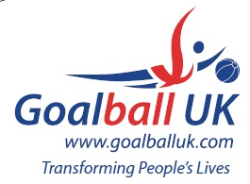

2014/15 League Winners

Novice Region A | Scarborough
Novice Region B | RNC Hereford
Intermediate Region X | Scarborough
Intermediate Region Y | Birmingham
Intermediate Region Z | Winchester
Intermediate Finals | Scarborough
Elite | Leicester
Goalfix Cup | Leicester
National | Winchester

