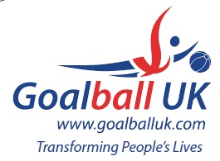

2018/19 League Winners

Novice Region A | Lancashire Lions/ West Yorkshire
Novice Region B | RNC Academy
Novice Region C | Croysutt Warriors
Novice Finals Tournament | Croysutt Warriors
Intermediate Region A | Scarborough
Intermediate Region B | RNC Academy
Intermediate Region C | Cambridge Dons
Intermediate Finals Tournament | Scarborough
Elite | Winchester
Goalfix Cup | Northern Allstars
National | RNC Academy

