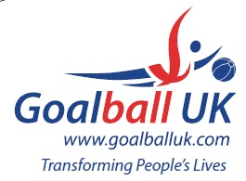

Goalball UK Shield (previously named Novice Shield pre-2022) Winners
2023 | Winchester Kings
2022 | RNC Academy
2021 | N/A (Covid-19)
2020 | N/A (Covid-19)
2019 | Croysutt Warriors
2018 | RNC Academy
2017 | Fen Tigers
2016 | Croysutt Warriors

