Goalball UK Project Group

Survey Findings, March 2023

What did we do?
- Online Member Survey between December 2022 and February 2023
- Aiming to investigate the experiences of women and girls already involved in goalball:
  - Including how the level of vision impacts sports participation, what they find most enjoyable about goalball, challenges faced when first entering the sport and how they think the participation of women and girls can be increased.

44 participants responded!
- 8 Female Junior Players (5 with a Severe VI, 1 with a VI, 2 with no VI; 6 x Congenital VIs).
- 20 Female Adult Players (7 aged 18-24, 9 aged 25-34, 4 aged 35-49; 13 with a Severe VI, 7 with a VI; 11 x Congenital VIs, 7 x Acquired VIs, 2 unknown).
- 11 Adult Workforce (2 aged 18-24, 2 aged 25-34, 2 aged 35-49, 5 aged 50+; 11 with no VI).
- 5 Male Adult Players (3 aged 18-24, 2 aged 25-34; 5 with a Severe VI; 4 x Congenital VIs, 1 x Acquired VI).

What did we find?

Results from the question ’How does your vision impact on your participation in sport?’ were split into three themes: Lack of Accessibility, Required Adaptations and Lack of Inclusivity:

Theme 1: Lack of Accessibility
- I couldn’t access the sports I wanted to
- Handouts and instructions are too small
- Access to transport to attend sporting events
- Unable to see demonstrations
- Opportunities are a postcode lottery [for someone with a VI]

Theme 2: Required Adaptations
- I need sports to be adapted (guide runner, bells with balls)
- [My VI] restricts involvement in sports that aren’t adaptable
- I require assistance from a sighted guide

Theme 3: Lack of Inclusivity
- [My visual impairment] makes me feel unwanted and unwelcome. Sometimes I’m too blind, others I have too much vision.
- No one trusted to pass the ball to me.
- I just find that I can’t compete with sighted opposition, so it makes it not fun.
- Difficult to see equipment, notice obstacles and where teammates are.
- It would be unsafe for me and the other participants due to me not having enough sight.

Results from the question ’What do you find most enjoyable about goalball?’ were split into three themes: Inclusivity, Sense of Community and Empowering:

Theme 1: Inclusivity
- I know that goalball will always be fully accessible to me, and I won’t feel like the odd one out
- Everyone is on a level playing field
- Playing a sport alongside my sighted family
- Playing a sport where vision doesn’t matter
- Less patronising and condescending than other VI sports

Theme 2: Sense of Community
- Making new friends - ‘they feel like more than teammates’
- Enjoy being part of a team and the team spirit
- Everyone has the same aspirations

Theme 3: Empowering
- I have learnt so much about living with a VI because of meeting people through goalball.
- Ability to have independence and show skill, despite disability.
- Goalball has made me realise I can do more than I thought I could.
- Travelling and competing against others around the country and the world.

Results from the question ‘What challenges did you face when first starting goalball?’ were split into four themes: Club Availability, Lack of Confidence, Finance and Competition Structure:

Theme 1: Club Availability
- No local teams and Unable to travel alone

Theme 2: Lack of Confidence
- Trying something new - ‘I didn’t know what goalball was’
- Managing goalball alongside life commitments
- Taking time to get used to the sport

Theme 3: Finance
- Equipment - ‘We didn’t know what equipment we needed’
- Training and Competition Expenses
- Cost of living crisis
- Impact of train strikes

Theme 4: Competition Structure
- The first level of competition [novice] is too high… it needs to be more accessible to new players
- There is a gap in ability between levels
- Want to compete against players’ own age
- The fact that men dominate due to strength or being taller
- For female players who want to get to the GB level, there has not been a strong talent pathway established for female athletes so it’s difficult to know how you could breakthrough into the GB squad

Results from the question ‘What can Goalball UK do?’ were split into four themes reflecting the challenges faced (Club Availability, Lack of Confidence, Finance, Competition Structure) plus an additional theme: Raise Awareness

Theme 1: Club Availability
- Have more clubs around the country
- Support improvement of travelling skills and make sure women/girls feel safe travelling to/from sessions

Theme 2: Lack of Confidence
- Introduction/1-2-1 sessions with a coach/elite player to cover basics, address questions and ease people in
- Advertising that you get to build up slowly, safely and in a way that you are still contributing to the team
- Remove the ‘fear that you’re going to be blindfolded & have a heavy ball thrown in your face at high speed’
- Childcare provisions

Theme 3: Finance
- Having equipment like chest guards that are best suited to goalball and are a reasonable price

Theme 4: Competition Structure
- Female-only sessions including tournaments and sponsored training sessions and/or age-specific sessions.
- Establish a stronger talent pathway for female players (consult other NGBs on methods they’ve used).
- Making sure there is a good representation of women and girls on the competition committee.

& Raise Awareness
- Advertise goalball in female settings, such as all-girls primary/secondary schools, community groups and VI charities (e.g., Victa family weekends away) and/or use blind female influencers.
- Improve the advertisement of GB women’s games and showcase their success!
- ‘I don’t know where to watch these or when they’re on’.
- Have more women in professional positions like coaches (and run female-only coaching courses).
- Use women in publicity / social media – actively share the GB women’s squad on social media.
- Success stories give someone to admire/look up to.

Participants were asked to select the top three strategies for improving the participation of women and girls in goalball.

Image below showing a chart of the strategies to enhance women and girls experience in goalball. Photo description in alt text.
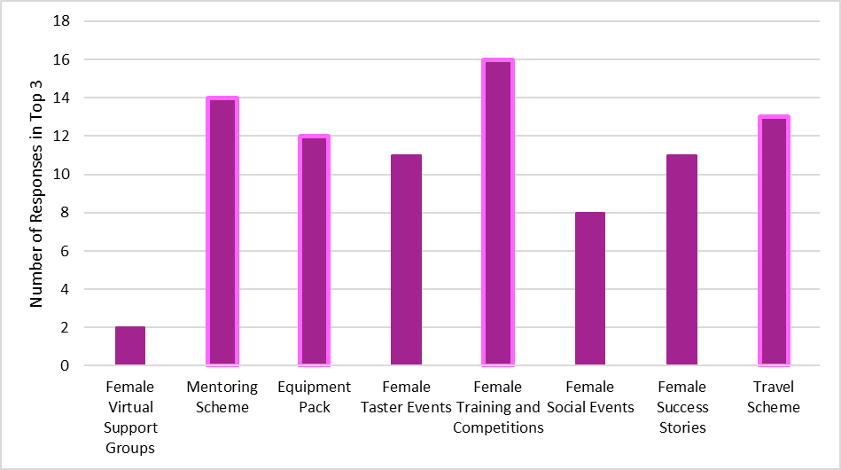

Top four strategies: Female-only training sessions and competitions, mentoring scheme, travel scheme, equipment pack. Support for these ideas included:

Female Only Training Sessions and Competitions
- A great way to put the spotlight on female players.
- Provides an opportunity for those who don’t feel comfortable with facing male shots yet.
- Build confidence before mixed training sessions.
- A good way to introduce women and girls to the sport and show them that they can play.
- I’m cautious, as I worry this may be a slippery slope towards segregated domestic competitions.

Mentoring
- I had a buddy when I joined the academy & it was helpful; I made a friend & asked lots of questions.
- It would be a friendlier introduction to the sport as new players may be shy or nervous.
I think socialising will increase a feeling of belonging, identity and confidence for women and girls.
- I don’t think it needs to be in the same club – especially for clubs that do not have a lot of female players.

Travel Scheme
- Entrances into buildings can be difficult to find if it's your first time even for sighted people.
- Reassure players if the train station and/or area is unfamiliar to them.

Equipment Pack
- May help new players to feel valued as new members and encourage them to come back.
- I'm sure plenty would appreciate a chest guard! They are an expense male players don’t have.
- You could work with Goalfix to have discounted chest guards for Goalball UK members as they are the first of their kind that many of us have found to be effective but they’re eye-wateringly expensive.

What are the next steps?
- Using the responses from the online survey, the This Girl Can Project Group have selected three main strategies for increasing the participation of women and girls in goalball.
- Each member of the Project Group has been assigned to implement one of these strategies!

Equipment Pack: Alex, Alex C and Tracy

Aim: To source and provide an equipment pack to new members. Also, to coordinate an online ‘Introduction to Goalball Equipment Session’ and an Equipment information pack.

Mentoring Scheme: Lois and Anna

Aim: To design and implement a coherent mentoring scheme across GoalballUK for women and girls. To recruit and induct mentors and buddies onto the scheme.

Female-Only Training Sessions and Competitions: Emerlyne and Rachel

Aim: To organise and implement a female-only competition, building on the This Girl Can Open (Feb 2023).

In addition to these three strategies:
- Survey findings are to be passed to Goalball UK and promoted across Goalball UK network
- Awareness strategies to be shared with Goalball UK Social-Media
- Competition Feedback is to be shared with Goalball UK’s Competition Committee
- Travel Scheme Feedback is to be revisited by the project group, and Goalball UK, as a potential future strategy

