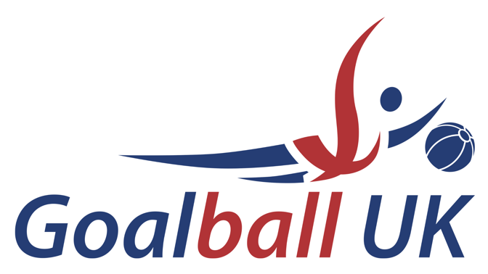

Performance and Talent

Advisory Group

Terms of Reference

November 2021

Performance and Talent Advisory Group Terms of Reference

Introduction
The Performance and Talent Advisory Group (the “Committee”) is a Committee of Goalball UK.
The Committee has been established to support the Board in their responsibilities for strategic matters and issues relating to the elite performance and talent and development of the sport including all technical aspects and reviewing the reliability and integrity of the Performance and Talent Programmes.
The Committee is authorised by the Board to seek any information it requires from any employee or consultant of Goalball UK to perform its duties.

Composition
The Committee shall consist of up to six members, at least one of which shall be a non-executive member of the Board, an athlete and one of which shall be the CEO.
The Committee will be chaired by a non-executive Director. In the absence of the Chair, the Committee may nominate another Board Member to deputise in their absence.
Other members may be any nominees appointed by the Board or any member of staff, from time to time.

Reporting
Where reasonably possible, minutes of each Committee Meeting will be tabled to the subsequent Board meeting and, where necessary, the Chair of the Committee will provide a report to the Board on any substantive matters of importance and any material issues or concerns.
The Committee will provide the Board with an Annual Report, timed to support finalisation of the accounts, summarising its conclusions from the work it has done during the year.
The Committee shall make whatever recommendations to the Board it deems appropriate on any area within its remit where action or improvement is needed.

Responsibilities
The Committee will advise the Board on:
- the Strategic development of the elite performance and programme.
- the strategic development of the athlete development programme.
- the Strategic development of youth development and identification (talent pathways).
- the development of a major events strategy and hosting of major championships.
- the development of all discipline, selection, and appeals procedures.
- the development of sports support programmes to include sports science, medicine, and duty of care of athletes.
- the development of an Anti- Doping strategy in-line with UKAD and WADA requirements.
- the on-going development of officials.
- the on-going development of coaches (technical & maintaining standards).
- the maintenance of rules and regulations.
- strategic input into international relations planning.
- the representation of the organisation internationally; and
- the Committee will also periodically review its own effectiveness and report the results of that review to the Board.

Rights

The Committee may:
Co-opt additional members to provide specialist skills, knowledge and experience; any such positions will be reviewed one year after their appointment.
Appoint independent non-Board members for a period of three years, which may be extended for further periods (normally up to three years), subject to the approval of the Board;

Procure specialist ad-hoc advice at the expense of the organisation, subject to budgets agreed by the Board.

Access
The External Auditor will have free and confidential access to the Chair of the Committee.
Meetings
The Committee will meet at least four times a year. The Chair of the Committee may convene additional meetings as he or she deems necessary.
The Committee meetings will normally be attended by the Office Manager who will provide a secretariat service to the Committee, and a representative of the External Auditor as required.
The Committee may ask any other officials of the organisation to attend to assist it with its discussions on any particular matter.
The Committee may ask any or all of those who normally attend but who are not members to withdraw to facilitate open and frank discussion of particular matters.
The Board may ask the Committee to convene further meetings to discuss particular issues on which they want the Committee’s advice.
Meeting papers will be circulated no later than five (5) working days ahead of each meeting.
Quorum
A minimum of five members of the Committee, one of whom must be a non-executive member of the Board and one of whom must be the CEO who must be present for the meeting to be deemed quorate.
Resolutions and Voting
Decisions of the Committee shall be taken by resolution and recorded in the minutes of the meeting at which such a resolution is passed.
Where a consensus cannot be agreed, the Chair may request a vote on a show of hands, in which case each Committee Member shall have one vote. In the case of a tie the Chair has the casting vote.
Terms of Reference and Committee Effectiveness
The Committee’s terms of reference and effectiveness will be reviewed at least annually by the Board and the Committee, including a review of membership and relevant skills and any changes considered necessary must be approved by the Board.

