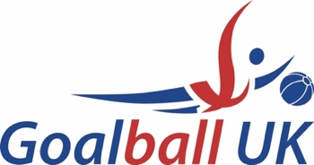

Performance Pathway Programme
Appeals Procedure

There are no appeals allowed against the content of the criteria for invitation and therefore against the actions of the selection panel, provided they follow the published criteria.

Appeals will only be considered on the grounds that:

- there has been a failure to follow the process outlined in the criteria for invitation; the departure from the process is more than minimal and has a material impact on the outcome.
- the panel, or any member of it involved in making the relevant invitation decision has shown actual bias when making the decision;
- the panel reached a decision on the basis of an error of fact; or
- the decision is unreasonable and one that no reasonable decision maker could ever have reached.

If none of these grounds are met the appeal will be dismissed

- An Athlete (the Appellant) may appeal to have the decision of the Goalball UK selection panel reviewed by the Appeals Panel.

- The Appellant should lodge an appeal in writing within 48 hours after the decision has been communicated to them to mark.winder@goalballuk.com Receipt of selection will be assumed no later than two hours after the selection email has been distributed.

- The notice of appeal should set out in full the basis of which the Appellant wishes to appeal and should be accompanied by all relevant and supporting documentation.

- The Appeal panel will meet via Microsoft Teams/ Zoom within 5 days of the appeal being received, where the Appellant will be invited to attend and is permitted to bring an advocate to support, but not speak on behalf of, the Appellant. If the Appellant is unable to attend a decision will be made based on the previously submitted documentation. Goalball UK have 5 working days to communicate a response to the Appellant.

- The decision of the appeals panel is final, and the appellant has no further right to appeal.

- Members of the Appeals panel will have had no previous involvement in the invitational criteria and one member will be from out with Goalball UK.

Updated March 2024

