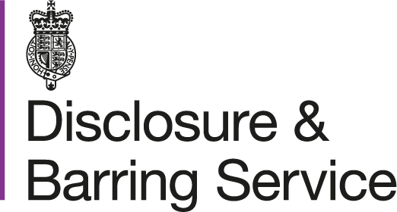

How to subscribe to the Update Service

- Go to https://secure.crbonline.gov.uk/crsc/subscriber
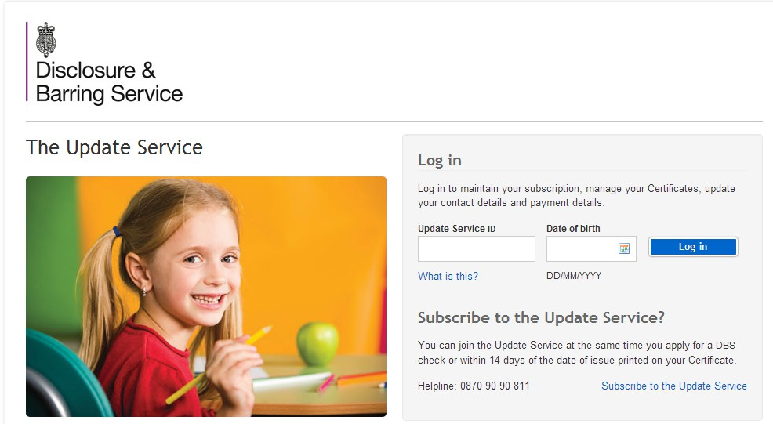

Select “Subscribe to the Update Service”

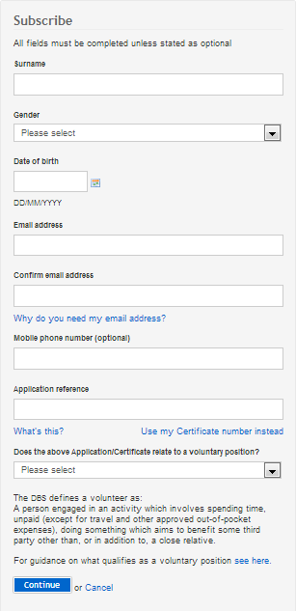

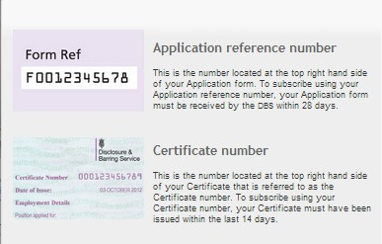

If you are a paid Coach you need to select No

- Read and Accept the Terms and Conditions
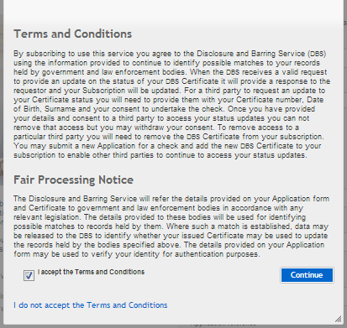

- You will need to make the annual payment to the DBS (if you are a paid Coach)
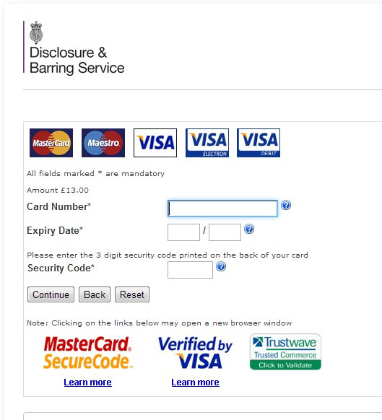
- Once payment has been received this confirmation note will appear

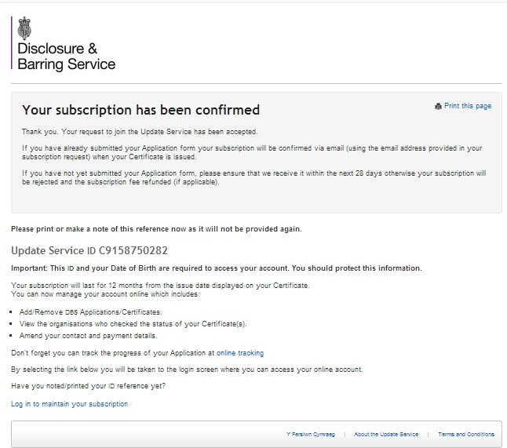
Update Service ID Number

- Using your Update Service ID and Data of Birth you can log in

- These are the different stages of processing
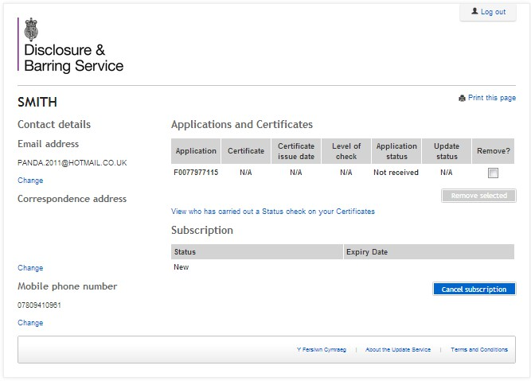
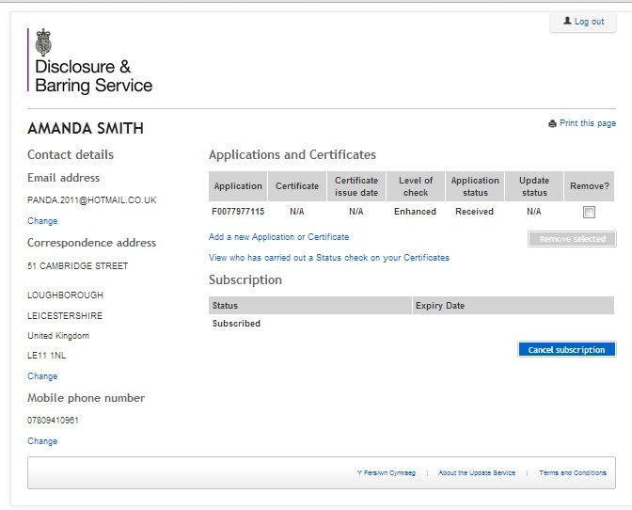

This indicates the DBS are processing your application

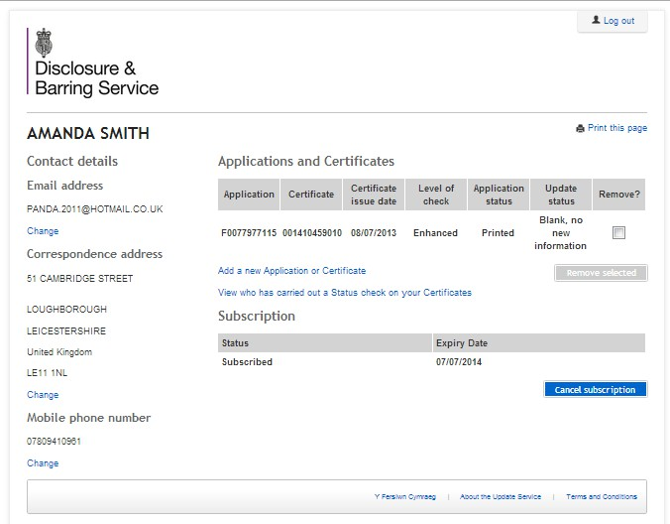
Here you can see who has carried out a Status check

