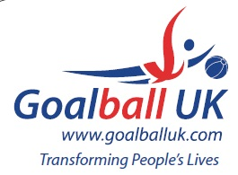

2025-2026 League Winners

Regional
Region A Winners – Greater Manchester Falcons
Region B Winners – RNC Academy
Region C Winners – Watford Wizards

Intermediate
North Winners – Blackburn Bullets
South Winners – Croysutt Warriors

Super League
Super League Winners – Fenland Tigers

Cups
2026 Goalball UK Shield Winners – Winchester Kings
2026 Intermediate Trophy Winners – RNC Academy
2026 Goalfix Cup Winners – Fen Tigers

