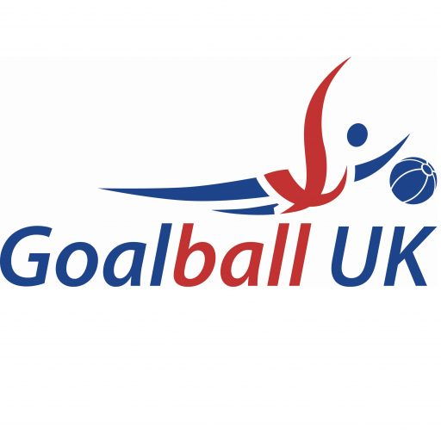

Assistant Performance Coach Voluntary (X2)

Closing Date: 21st October 2026
Job Reference: GOA011

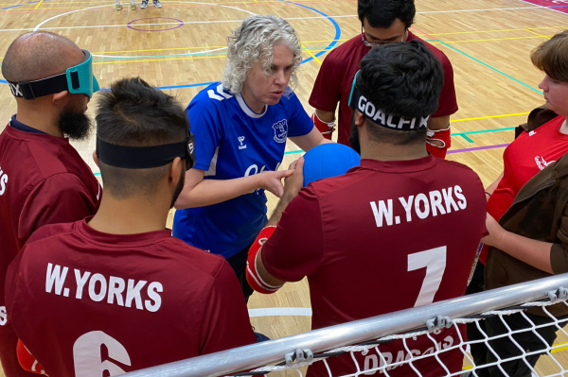
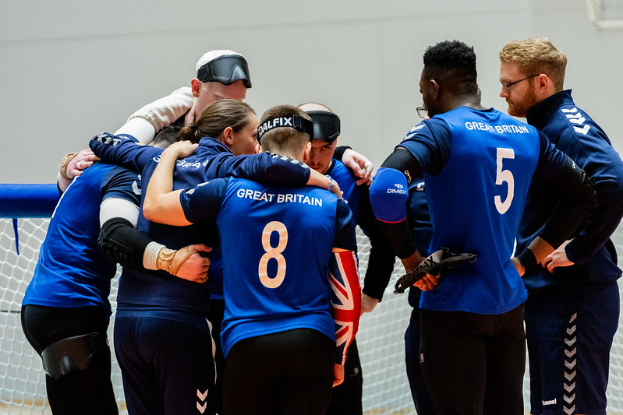

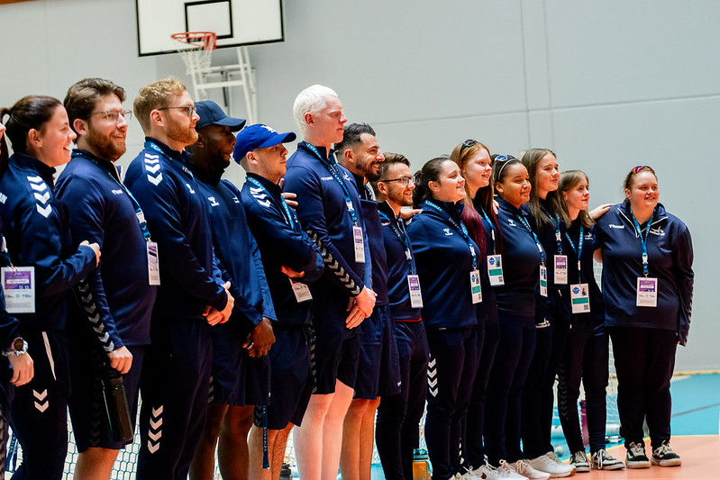

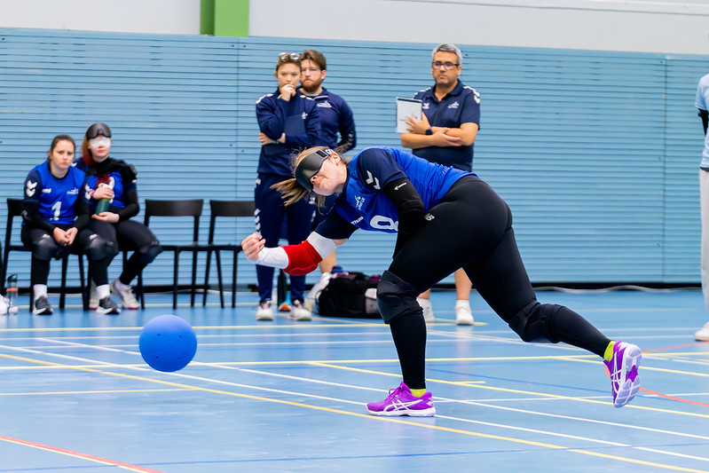



Job title:
INTRODUCTION
Assistant Performance Coach (2 posts) (Voluntary)

About Goalball UK:
Watch this video

Goalball is a fast-paced, action-packed, 3-a side indoor game of attack and defence designed for people who are blind or partially sighted. It is a unique Paralympic sport, with no Olympic equivalent and is played by both men and women.

Funded by the National Lottery and Exchequer, through both Sport England and UK Sport, Goalball UK is the governing body, with charitable status, responsible for the sport of goalball in the UK.

We are about to launch our Empowering People Strategy: As a core part of this strategy, we are committed to developing players from within our sport and building a robust and sustainable talent and performance pathway. If you join Goalball UK, you will work in a progressive, caring, inclusive, charitable organisation that takes pride in truly ‘Transforming People’s Lives’.

We pride ourselves on being bold in our words and actions in supporting the ‘Goalball Community’ on their transformational journeys. We are committed to challenging other inequalities and reducing the barriers to participation and improving the life chances of all people with a visual impairment (V.I.).

It is an exciting time to join Goalball UK, both men and women’s Great Britain teams have retained their position in the European A Championships, and we will be working towards achieving World Championship qualification for 2026 with the longer-term goal of qualifying for the Los Angeles 2028 Paralympic Games. This role will be integral to our success in these games and beyond.

About the role:
An exciting opportunity to work in our Performance Programme as an Assistant Performance Coach, building on the commitment and efforts of athletes, staff, and volunteers within our sport in the UK.

We are looking for skilled, enthusiastic, innovative people to develop the coaching programmes, system, and individuals throughout the next Paralympic cycle.

These exciting positions will play a pivotal role in supporting the development of the Performance Programme, as well as the performance culture within our sport.

Applicants need not have previous experience with goalball, and we are particularly interested in
hearing from coaches with high performance experience from other sports.

We will provide full training and CPD opportunities to support.

How to apply:
Closing date Wednesday 21st October 2026 (Midday)

For informal enquiries, contact Gary Fraser, Goalball UK Performance Director, at gary.fraser@goalballuk.com. Applications sent to this address will not be accepted. To apply, send a current CV and a covering letter outlining your relevant experience and skills to Andrew Crawford at andy@crawfordhr.com. We also welcome alternative formats, such as video application.

Interview date Week Commencing 26 October 2026 (Online).

Job title: Assistant Performance Coach (Voluntary).
JOB DESCRIPTION
Responsible to: Goalball UK Performance Director.
Location: Sheffield and international tournaments and training camps.

Purpose of role: To assist the High-Performance Coaches in the creation and delivery of an athlete centred performance programme for selected players within our Centre of Excellence.

To support the design of the performance environment alongside the technical & tactical development of the players and teams enabling consistent success at World level.

To work alongside high-performance coaches and support staff to support the design and delivery of high-quality training and competition to enable the preparation of players and teams.

Key relationships: - Athletes
(Internal) - Performance Director
- Talent Director
- Programme Practitioners
- Goalball UK coaches, staff, and volunteers

Key responsibilities:
- To be a member of the Goalball UK Performance Coaching team, developing, and maintaining a high-quality training and playing environment.
- To support the technical, tactical, and physical development of selected players within the Centre of Excellence.
- To deliver individual or small group regional sessions for specific players in conjunction, and support of the Head Performance Coaches.
- To support the development and monitoring of Individual Athlete Plans (IAP’s) for each selected player to enhance their performance in line with the programme plan.
- To develop relationships with all athletes and staff members across the Performance Pathway Programme.
- To support blind and visually impaired athletes on and off the court.
- To support the preparation and coordination of all aspects of the teams technical & tactical preparation for international competition.
- To contribute to the recruitment, evaluation, and selection of athletes within the pathway.
- To support the support services required by the athletes, coaching, team management and sports science support.
- To learn, develop and be part of a growing coaching network within the sport.

Other requirements:
- Any other duties identified by the Line Manager that are within the capabilities of the post holder and which enhance the existing and developing needs of Goalball UK.

Ongoing development and training:
- To fulfil the requirements of the role and to maintain continuous professional development (CPD) there will be the need to undertake additional training as identified or required.

Summary of terms and conditions:

Contract type | Volunteering agreement.
Anticipated commitment | Up to 30 days per year.
Rate of pay | Voluntary, with expenses. We anticipate moving this to a day rate.  payment once upskilled.
Contract start | As soon as possible.
Working hours | Goalball UK are not obliged to provide the Contractor with any work  and the Contractor is not obliged to accept any work offered.
Working pattern | The Goalball UK programme operates a camp-based model, which  affords flexibility to how this role may be fulfilled.
References | Appointments are made subject to satisfactory references.
Disclosure | Due to the nature of this post, appointment will be subject to a  satisfactory Disclosure & Barring Service (DBS) disclosure.
Right to work | It is a requirement that the successful applicant demonstrates their  right to live and work within the United Kingdom complying with any  request made by Goalball UK around this.

Please note: This job description is not to be regarded as exclusive or exhaustive. It is intended as an outline indication of the areas of activity and may be amended from time to time. The post holder may be required to undertake any other duties as may reasonably be required which are commensurate with the post.

Role title: Assistant Performance Coach (Voluntary).
PERSON SPECIFICATION

Responsible to: Goalball UK Performance Director

 | Essential | Desirable | Method
Education and Training
A minimum Level 1 award and working towards level 2 in any sport. | Yes |  | CV, Q, I
Able to communicate fluently in English, both verbally and in writing. | Yes |  | CV, I
Skills and Experience
Have an understanding of performance sport programmes. | Yes |  | CV, I
Have an understanding of athlete development plans. | Yes |  | CV, I
Demonstrate coaching and leadership qualities. | Yes |  | CV, I
Experience of working with people with sight loss. |  | Yes | CV, I
Qualities or Aptitudes
A good understanding of how individual players are motivated with the ability to vary approaches to develop best performance and to bring the best out of existing talent. | Yes |  | CV, I
Able to motivate and influence behavioural change to have a positive impact on performance. | Yes |  | CV, I
Any Other Requirements
Willing and able to sign, adhere to and work within all policies and to commit to undergo relevant training as identified necessary by your Line Manager, including but not exhaustive to selection, anti-doping, safeguarding, equality, and data protection. | Yes |  | I
Wiling to learn and continue personal development as a coach. | Yes |  | I
To act in the best interests of Goalball UK through developing and maintaining a good understanding of our culture and values. | Yes |  | I
Flexibility to work irregular hours and a commitment to travel and attend training camps as advised by Goalball UK that include overnight stays and weekend working. | Yes |  | I
Satisfactory disclosure from the Disclosure & Barring Service (DBS). | Yes |  | DBS

CV Curriculum Vitae
I Interview
P Presentation
Q Proof of Qualification or Certificate

Disability:
GENERAL INFORMATION
Please let us know if you require adjustments making at any stage or to any aspect of this process or provide us with any information that you feel relevant whilst the process is ongoing.

If selected for interview, we will ask if you have any access needs or if you require any reasonable adjustments to be made.

We will be supportive in discussing reasonable adjustments at all stages of this process and if you have any questions or feedback about our recruitment and selection practices you can contact our external Human Resources Partner in confidence at andy@crawfordhr.com.

Entitlement to work in the UK:
Any job offer, be that on an employed or contractor basis, will be conditional, subject to confirmation that you are permitted to work in the UK in accordance with the provisions of the Asylum and Immigration Act 1996. You will be asked to provide evidence of your entitlement to work in the UK.

Experience, knowledge, skills, and abilities:
The person specification lists minimum requirements for this post. When shortlisting, the selection panel cannot make assumptions and are only able to assess the person specification against the information contained in your CV and/or on any application form that has been used.

References:
Any offer that is made to you, be that on an employed or contractor basis, will be conditional, subject to satisfactory references who can each comment on your suitability to the role.

Criminal convictions:
Anyone who applies to work with us, be that on an employed or contractor basis, will, at some stage, be asked to disclose details of unspent convictions. Having a criminal record does not necessarily bar you from working with Goalball UK but this of course depends on the nature of the conviction.

Data Protection:
The information provided in your CV and on your application form will be held in confidence. We process this information in line with our privacy policy. If you are successful, the information will be used to administer your employment or your contract for services with us. By signing any document where an offer is made to you, we assume that you agree to the processing of your data in this way.

Equality, Diversity, and Inclusion:
Our aim is to have a workforce that reflects a diversity of talent, abilities, and skills. In line with the Equality Act 2010, we will monitor the composition of our workforce to ensure it is representative and that staff are treated equally and fairly. Recruitment of staff and engagement of contractors will be made solely on the basis of ability and individual merit as measured against the criteria for the job.

Other Policies:
We have a range of policies and processes in place to protect you, to protect us and to safeguard those who use our services. Should a conditional be made to you and be that on an employed basis or through a contract for services, you commit to work within and promote these at all times.

They include, but they are not exhaustive to Health & Safety, Data Protection, the General Data Protection Regulation, Information Governance, Safeguarding, Performance Management, Equality, Diversity and Inclusion, Confidentiality and a range of Personnel and Financial Processes.

