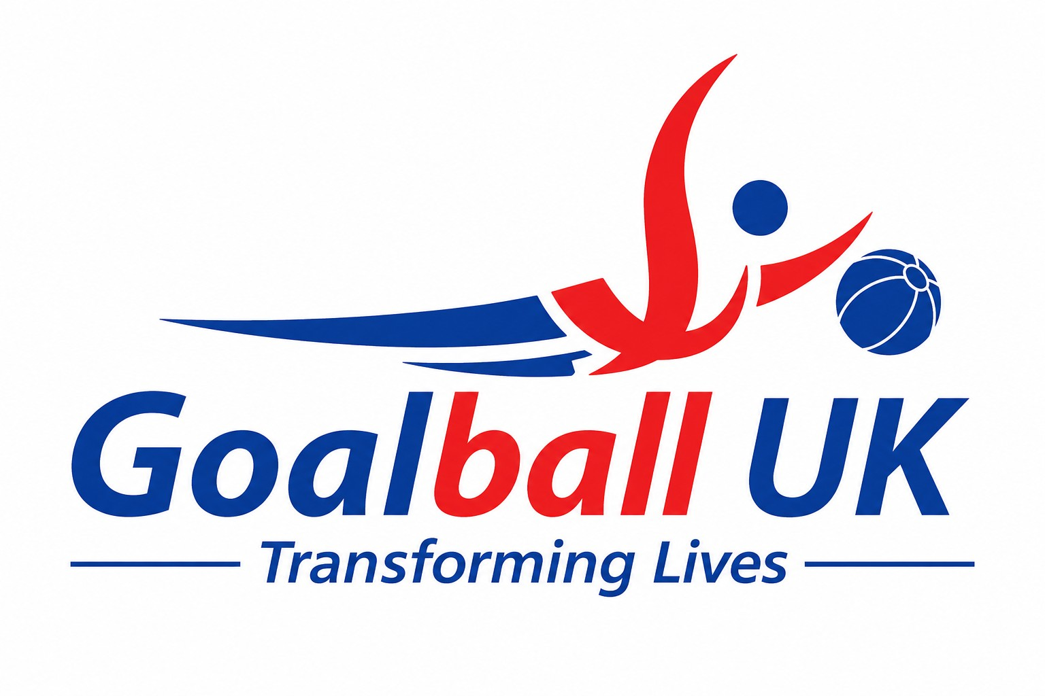

Non-Executive Director

1. Closing date: | 30 November 2026 (noon)
2. Interview date: | 4 December 2026 (via MS Teams)



Goalball is more than a sport, it transforms lives. Goalball helps participants build independence and well-being; as well as providing an inclusive community and sense of belonging.

Goalball UK is the National Governing Body for the Paralympic sport of goalball in the UK. There are currently over 30 active clubs in the UK and Goalball UK oversee the sport from grassroots through to the Paralympics.

Goalball is a fast-paced 3-a-side team game where the aim is to score past the opponent by throwing a weighted, bell filled ball toward their goal. Players block the ball with their bodies, and all players wear black out eyeshades to keep vision levels equal.


The game was invented in 1946 to rehabilitate soldiers who had lost their sight in the War, and it has been played over the world ever since. Making its Paralympic debut in 1976, there is no able-bodied equivalent.

We work to promote and provide sporting opportunities to blind and partially sighted people, UK-wide.

Click to watch our explainer video to learn more about the sport of goalball:

You can learn more about the positive impact we have on people’s lives through our website and our @goalballuk Facebook and Instagram social feeds.

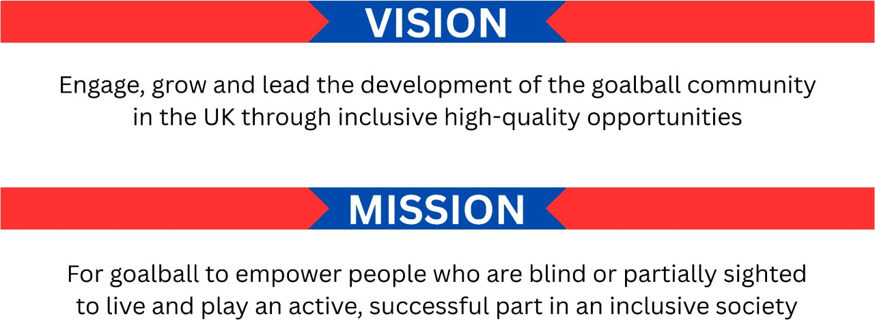



On behalf of the Board of Goalball UK, I am delighted to introduce this exciting opportunity to join our team as a Non-Executive Director.

This is a pivotal role within our governance structure, providing vital independent oversight and challenge as we continue to grow and develop as an organisation.

As a Non-Executive Director, you will play a key role in our strategic direction, ensuring robust governance practices are maintained, safeguarding the interests of Goalball UK and its stakeholders.

We are seeking individuals with a strong commitment to our mission of empowering blind and partially sighted people through sport.

You will bring experience in governance, strategic thinking, and leadership, and a genuine passion for promoting inclusivity and excellence in sport.



Ian Clarke
Chair of Trustees

As Chair, I am committed to fostering a collaborative and supportive Board environment where diverse perspectives are valued and respected. You will have the opportunity to work closely with myself and other Board members to ensure that Goalball UK continues to thrive and make a positive impact on the lives of many.
We are particularly seeking individuals with experience in either:

- Finance and Financial Oversight
You will bring senior financial experience and the ability to scrutinise accounts, budgets, and cashflow forecasts, and to challenge and gain assurance from our external auditors and CFO. Your independent judgement will help safeguard our financial sustainability, including oversight of cash, reserves, and going concern. Charity or grant-funded sector experience and risk management experience are welcome but not essential.

- Income Generation and Charity Fundraising
You will help shape our approach to attracting funding, building donor and partner relationships, and developing sustainable income streams that enable us to grow our sport and deliver our charitable purpose.

I encourage you to read the accompanying job description and person specification to learn more about this exciting opportunity and to contact me if you have any questions.



I am privileged to lead a passionate and dedicated staff team, who are proud and committed to making a positive difference in the lives of blind and partially sighted people.

We are in the second year of our ‘Empowering our People’ strategy (2025 and beyond), building on the growth of our charity over the last 15 years.

The strategy is built on a foundation of listening. We have engaged with our community to understand their needs and aspirations, and it is clear there is a desire for more opportunities. That is why we focus on six strategic obsessions:

- Growing and developing our players: Providing pathways for participation and excellence at all levels.
- Growing and developing our workforce: Investing in the skills and passion of coaches, officials, and volunteers.
- Providing high-quality experiences: Creating safe, inclusive, and enjoyable environments for everyone.
- Creating and developing partnerships: Collaborating with organisations and individuals who share our vision.
- Improving our organisational health: Ensuring we are a sustainable and effective organisation.
- Raising awareness: Sharing the inspiring stories of goalball and the incredible people who make it happen.



Mark Winder
Chief Executive Officer

We are incredibly excited about the future of goalball in the UK.

The successful applicants to the post of non-executive director will become an integral part of the Goalball UK team – supporting the Board, Senior Leadership Team, staff, and volunteers to shape the amazing sport of goalball in the UK.



Job title: Non-Executive Director (Voluntary)

Location: Flexible.
Whilst a number of meetings are held remotely, we envisage attendance in person at some meetings and events will be necessary, for which expenses can be claimed.

Responsible to: Chair of the Board of Trustees

Internal relationships:

Purpose and objectives

Key responsibilities:
- Goalball UK Trustees
- Goalball UK Staff Team
- Leadership Team.
- Faculty.

- The Non-Executive Director (NED) will play an active part in providing oversight and challenge to the Board of Goalball UK.
:

- Working collaboratively with trustees of Goalball UK the NED will ensure effective governance whilst safeguarding the interests of Goalball UK.

- Provide independent perspective and challenge: Offer objective and constructive input on strategic decisions, risk management, and organisational performance.
- Chair Board committees (as required): Lead specific Board committees, depending on knowledge, skills and understanding, ensuring effective functioning and compliance.
- Champion good governance: Promote high standards of governance and ethical conduct throughout the organisation.
- Safeguard stakeholder interests: Ensure that the Board considers the interests of all stakeholders, including players, members, staff, and funders.
- Contribute to Board development: Participate in Board training and development activities to enhance collective effectiveness.



Essential:

Independence: | Demonstrable independence from Goalball UK, with no  conflicts of interest that could impair objective judgment.
Strategic thinking: | Ability to think strategically and contribute to the  development of long-term organisational goals.
Leadership skills: | Experience of leading and influencing others, with the ability  to chair meetings and facilitate discussions effectively.
Interpersonal skills: | Excellent communication and interpersonal skills, with the  ability to build relationships and work collaboratively.
Commitment: | A genuine interest in and commitment to the mission and  values of Goalball UK.
Expertise: | Experience in finance and auditing and/or income generation and charity fundraising.

Desirable:

Board experience and governance: | Experience as a Non-Executive Director or Trustee and comprehensive knowledge of good governance principles and practices.
Knowledge of sport: | Familiarity with the challenges and opportunities facing disability sports within a high-performance environment.
Not for profit: | Demonstrable experience of working within, for or on behalf of the not-for-profit sector (third sector, voluntary or  charity) where creating social value was paramount.
Marketing/Communications: | A strategic thinker with experience in developing and  executing marketing campaigns.
Social value: | Understanding of how to engage and influence decision makers to prioritise the positive impact of Goalball UK through the wider community through sustainable practices and philanthropy.
Environmental: | Experienced in promoting and guiding on environmental matters; with an understanding of how to integrate environmental, social, and economic considerations.
Lived experience: | Having personal experience to support and increase the  boards understanding, providing an authentic voice.

Anticipated time commitment:
- Attendance at approximately four Board meetings per year (both in-person and remote).
- Attendance at relevant committee and sub-committee meetings.
- Attendance at other events as agreed.
- Sufficient time for the review, comment, and as necessary preparation of Board papers.

Remuneration:
- The post of a Non-Executive Director is one of trusteeship and is voluntary.
- Appropriate out of pocket expenses will be made.



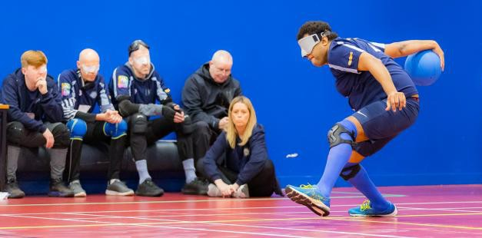
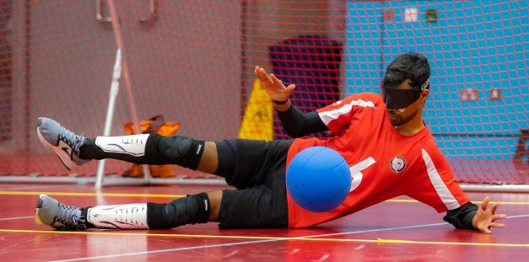
We are committed to equality of opportunity and building a diverse team. As part of this commitment, we encourage applications from individuals regardless of age, disability, ethnicity, sex, sexual orientation and cultural or social background.

Our strategic obsessions are to:

- Grow and develop our players
- Grow and develop our workforce
- Provide high-quality experiences
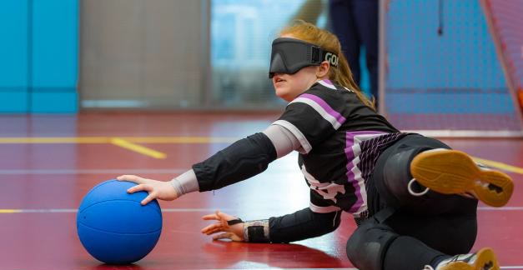
- Create and develop partnerships
- Improve our organisational health
- Raise awareness of the sport of goalball.




We encourage enquiries and questions about the role before making an application.

Such contact should, in the first instance, be addressed by email to Ian Clarke, Chair of Trustees, at ian.clarke@goalball.com.

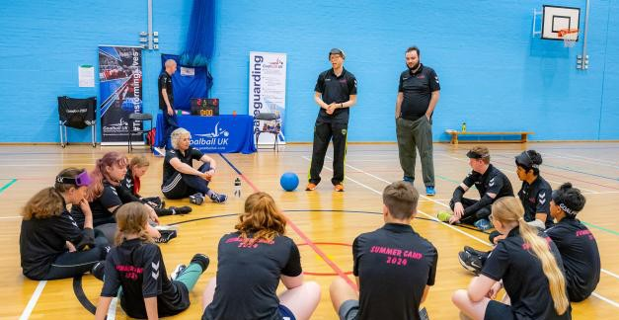
All enquiries will be treated in confidence.

To make an application you must complete an application form. (download here).

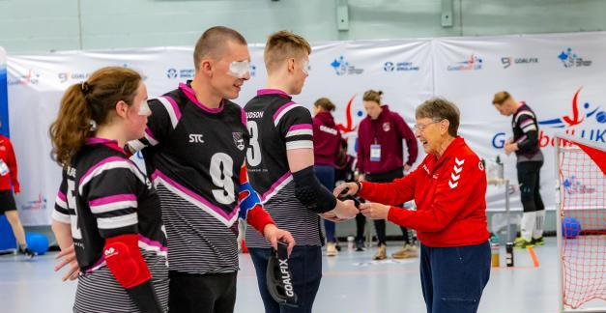
Return completed application forms, with a copy of your current CV and any supporting statements that you wish to include to Andrew Crawford at andy@crawfordhr.com before noon, 30th November 2026.

If you require adjustments making at any stage or to any aspect of this application process, please make us aware.

Interviews will be conducted via MS Teams.

